Electric Forklift – Model Maxx-1Ton 3 M
Product Overview
The MAXXLIFT 1 Ton Electric Forklift is designed for smooth material movement and safe lifting operations. It is ideal for warehouse loading and unloading tasks indoor logistics operations and light manufacturing units. This machine delivers strong performance zero emission operation and low maintenance cost with complete comfort for the operator.

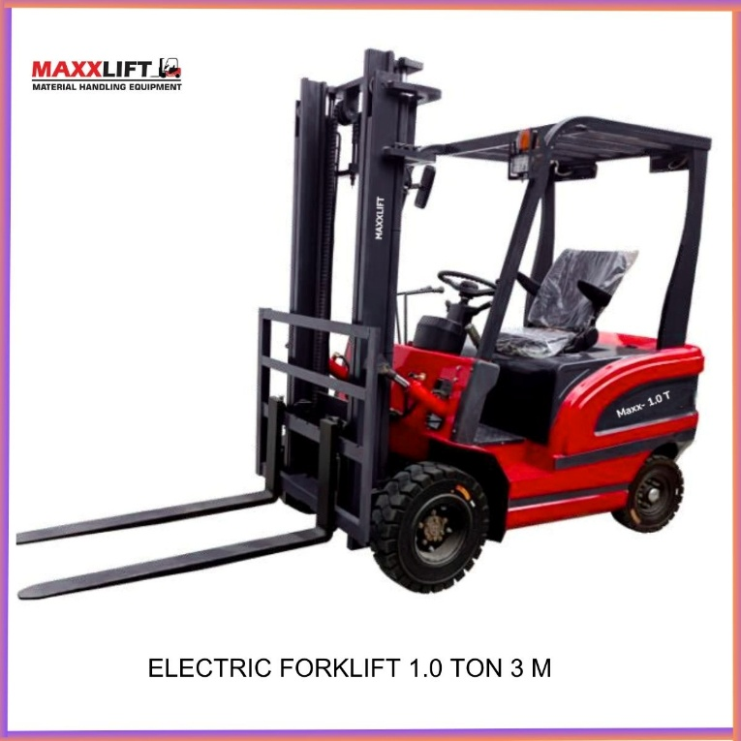
Video Section Add video link from YouTube or Instagram
Example
YouTube Link – https://www.youtube.com/watch?v=xxxxxx
Instagram Link – https://www.instagram.com/reel/xxxxxx
Showcase the forklift running lifting pallets charging battery or turning inside warehouse for better customer engagement
Machine Description
- Capacity 1 Ton (1000 kg)
- Electric battery operated type with strong traction motor
- Compact body designed for narrow spaces
- Fully electric operation suitable for warehouses factories logistics centers and indoor work
- Smooth lifting and lowering operation for safe material handling
- Silent working low vibration and zero pollutio

Technical Specifications
Parameter | Detail | Parameter | Detail
Model No. | Maxx-1.0 Ton | Rated Lifting Capacity | 1000 kg
Load Centre Distance | 500 mm | Maximum Lifting Height | 3000 mm
Inclination | 5 – 10° | Gradeability | 15°
Height of Roof Guard from Ground | 2100 mm | Minimum Ground Clearance | 40 mm
Fork Length | 1070 mm | Fork Width | 900 mm
Wheelbase | 1230 mm | Front Wheel | 500-8 mm
Rear Wheel | 400-8 mm | Battery Rated Voltage | 60 V
Battery Capacity | 325 AHS | Charging Time | 4 – 5 hours
Operating Hours | 6 hours | Drive Motor Power | 2000 W
Increase Motor Power | 1200 W | Weight Including Battery | 1.8 ton (approx.)
Dimension (L × W × H) | 1900 × 950 × 2200 mm | – | –

Where It Is Used
This forklift is used in
- Warehouses and storage units
- Manufacturing plants and assembly lines
- Transport and logistics hubs
- Packaging and loading bays
- Cold storage and food industries
- Chemical and pharmaceutical units
- Automobile component factories
Services and Support
MAXXLIFT provides complete service and support through trained technicians.
We offer
- Installation and operator training
- Preventive maintenance plans
- Spare part availability at branch locations
- On site service within 24 to 48 hours
Warranty
Standard warranty 12 months from the date of delivery covering major electrical and mechanical components under normal working conditions. Extended warranty options available on request.
Delivery Time
Normal delivery period 2 to 3 weeks after order confirmation and advance payment.
Faster delivery possible for ready stock units.
Delivery Locations
MAXXLIFT provides nationwide delivery including
Delhi NCR Haryana Punjab Rajasthan Uttar Pradesh Gujarat Maharashtra and other major industrial states across India.
Why Choose MAXXLIFT
- Indian manufacturing excellence
- Robust and efficient designs
- Reliable after sales support
- Spare part availability
- Trained technical team
- Trusted by top industries across India
Contact Details
MAXXLIFT MOTORS PRIVATE LIMITED
Main Highway NH 44 GT Karnal Road Kundli Sonipat Opposite KFC Restaurant Haryana
Haryana
Mobile: 9811679096, 7678272743, 9950921878, 9218058170
Website www.maxxlift.in

Electric Forklift – Model Maxx-1.5 Ton 3M

Overview
The MAXXLIFT 1.5 Ton Electric Forklift Model Maxx-1.5 is a heavy-duty electric machine built for powerful performance silent operation and zero emission working.
It is suitable for warehouses logistics centres manufacturing plants and industrial yards where efficiency and safety are critical.
This model combines robust structure advanced motor technology and operator comfort with low maintenance cost and long service life.
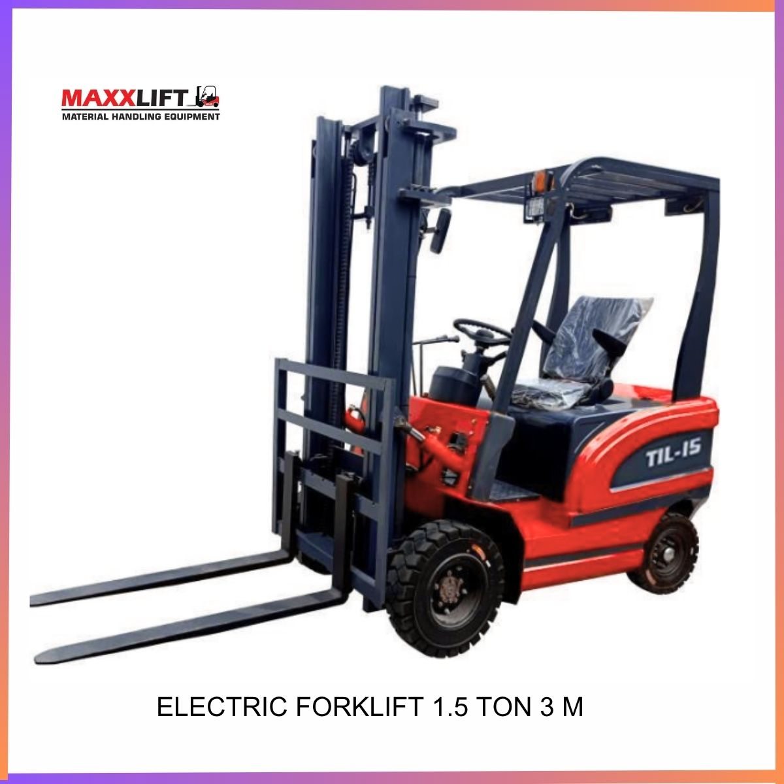

Product Video
YouTube – https://www.youtube.com/watch?v=XXXXXXX
Instagram – https://www.instagram.com/reel/XXXXXXX

Machine Description
The 1.5 Ton Electric Forklift offers smooth hydraulic lifting high torque power and durable structure.
It uses an advanced 3 kW AC travel motor and a 4 kW AC lift motor ensuring high energy efficiency.
Equipped with a double-cylinder mast made of special steel the forklift ensures stability and long-term durability.
Its class A solid tyres and thickened steel axles deliver strong ground grip and long life.
With a working battery capacity of 650 Ah and running hours up to 7-8 hours the forklift easily handles continuous industrial work.
Parameter | Detail | Parameter | Detail
Model No. | Maxx -1.5 Ton | Rated Load | 1500 kg
Travel Motor | 3 kW AC Super Quiet | Lift Motor | 4 kW AC First Stage Gear Pump
Drive Axle | 1:41 Ratio Cast Square Steel Bridge Wear Resistant Type | Steering System | Hydraulic Power Assist Microcomputer Control
Door Frame | Double Oil Cylinder Special Steel for Forklift | Steering Rear Axle | Thickened Double Steel Plate Bridge
Battery Capacity | 650 Ah | Output Voltage | 60 V
Battery Type | Lead Acid Battery Set | Battery Life | 7-8 Hours
Charging Voltage | 220 V | Charging Time | 4-5 Hours Intelligent Auto Stop
Raised Height | 3 m | Fork Length | 1.07 m (One-Piece Forged Anti-Wear Steel)
Body Size | 2.2 × 1.2 × 2.15 m (Excluding Fork Length) | Machine Height | 2.15 m (Can Be Lowered)
Weight (Self Respect) | 2200 kg | Counter Weight | Iron Slag + Cement
Tires (Class A Solid) | Front 650-10 Rear 500-8 Reinforced Type | Car Paint | Advanced Automotive Paint
Braking Method | Hand Brake | Drive Type | Electric Battery Powered

Where It Is Used
- Warehouses and storage units
- Manufacturing and production facilities
- Logistic and transport hubs
- Food processing and cold storage areas
- Automobile and engineering industries
- Ports and material handling yards
- Packaging and loading docks
Services and Support
MAXXLIFT provides complete after-sales support through expert service engineers and regional offices.
We offer installation training preventive maintenance and on-site breakdown service within 24 to 48 hours.
Genuine spare parts are stocked at all MAXXLIFT branches ensuring minimum downtime for customers.
Warranty
Standard warranty 12 months from date of delivery covering main electrical and mechanical components under normal use.
Extended warranty and annual maintenance contracts available on request.
Delivery Time
Normal delivery period 2 to 3 weeks after order confirmation and advance payment.
Immediate delivery available for ready stock models.
Delivery Locations
MAXXLIFT supplies and services equipment across India including
Delhi NCR Haryana Punjab Rajasthan Uttar Pradesh Gujarat Maharashtra and other major industrial regions.
Why Choose MAXXLIFT
- Proven Indian manufacturing quality
- Heavy-duty steel construction for long life
- Smooth and silent AC drive and lift motors
- Energy efficient and zero emission performance
- Wide service network and quick response team
- Reliable parts availability and after-sales support
Contact Details
MAXXLIFT MOTORS PRIVATE LIMITED
Main Highway NH 44 GT Karnal Road Kundli Sonipat Opposite KFC Restaurant Haryana
Mobile 9811679096 7678272743 9950921878 9218058170
Website www.maxxlift.in

Electric Forklift – Model-Maxx-2Ton 3M

Overview
The MAXXLIFT 2 Ton Electric Forklift Model Maxx-20 is designed for heavy-duty industrial handling operations where higher lifting power and long battery life are required.
It combines an advanced AC drive system with a strong double-cylinder mast built from high-grade steel for stability safety and performance.
This model supports lifting heights of 3 m / 4.5 m / 6 m to meet different warehouse and logistic requirements.
Product Photos

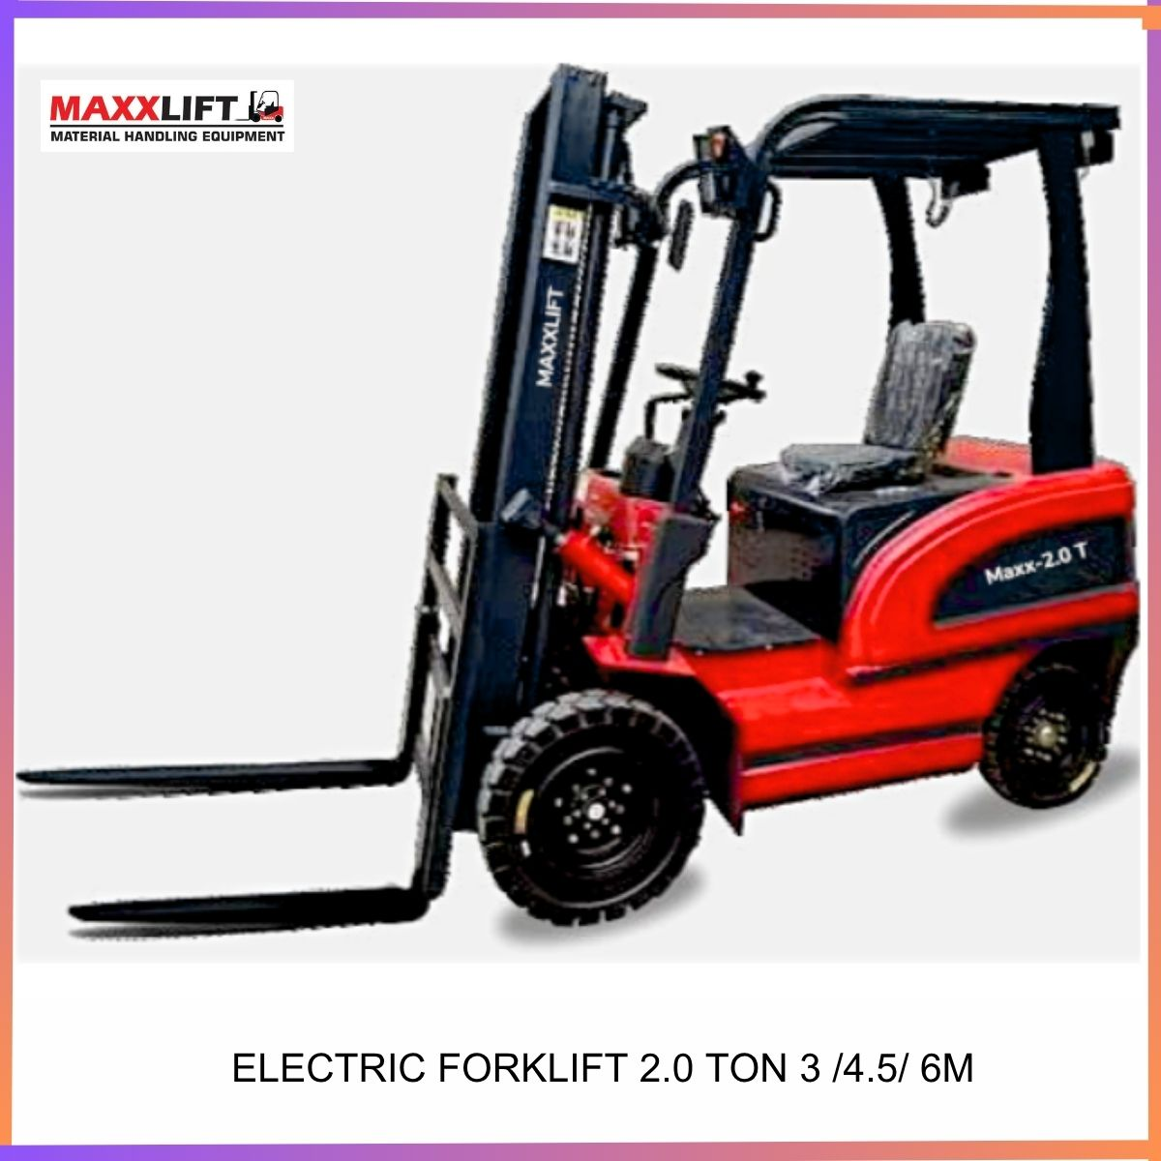

Product Video
YouTube – https://www.youtube.com/watch?v=XXXXXX
Instagram – https://www.instagram.com/reel/XXXXXX
Machine Description
The MAXXLIFT TIL-20 Electric Forklift delivers reliable performance for heavy loads up to 2000 kg.
It features a 4 kW AC super-quiet travel motor and a 5 kW AC lift motor for powerful yet silent operation.
The machine uses a double-oil-cylinder mast and a thickened steel axle ensuring high durability and stability under load.
It operates with a 60 V 650 Ah lead-acid battery offering 7 to 8 hours working time per charge.
The forklift uses Class A solid tyres reinforced for indoor and outdoor use and has advanced hydraulic power steering for smooth control.
The compact body and strong counterweight design provide balance and easy operation in confined spaces.
Parameter | Detail | Parameter | Detail
Model No. | Maxx-2.0Ton 3 M | Rated Load | 2000 kg
Travel Motor | 4 kW AC Super Quiet | Lift Motor | 5 kW AC First Stage Gear Pump
Drive Axle | 1: 41 Ratio Cast Square Steel Bridge Wear Resistant | Steering System | Hydraulic Power Assist Microcomputer Control
Door Frame | Double Oil Cylinder Special Steel for Forklift | Steering Rear Axle | Thickened Double Steel Plate Bridge
Battery Capacity | 650 Ah | Output Voltage | 60 V
Battery Quantity | 10 Pieces Lead Acid Type | Battery Life | 7 to 8 Hours
Charging Voltage | 220 V | Charging Time | 5 to 6 Hours Intelligent Auto Stop
Raised Height | 3 m / 4.5 m / 6 m (Customizable) | Fork Length | 1.07 m Anti-Wear Forged Steel
Body Size | 2.4 × 1.2 × 2.15 m (Excluding Fork Length) | Machine Height | 2.15 m (Can Be Lowered)
Self-Weight | 2700 kg | Counter Weight | Iron Slag + Cement
Tyres (Class A Solid) | Front 650-10 Rear 500-8 Reinforced Type | Car Paint | Advanced Automotive Paint
Braking Method | OHand Brake | Drive Type | Electric Battery Powered

Where It Is Used
- Warehouses and logistic hubs
- Manufacturing and assembly plants
- Material yards and packaging units
- Food processing and cold storage areas
- Automobile and engineering workshops
- Ports and industrial depots
- Indoor and outdoor handling sites requiring high-capacity lifting
Services and Support
MAXXLIFT provides complete after-sales service installation and operator training.
We offer preventive maintenance spare part availability and breakdown service within 24 to 48 hours.
Regional branches in Sonipat Gurugram / Gujrat/ Kundli and Bhiwadi ensure fast technical support across India.
Warranty
Standard warranty 12 months from the date of delivery covering main electrical and mechanical components under normal use.
Extended warranty and annual maintenance contracts available on request.
Delivery Time
Normal delivery period 2 to 3 weeks after order confirmation and advance payment.
Immediate delivery available for ready stock models.
Delivery Locations
MAXXLIFT delivers machines to all industrial locations in India including
Delhi NCR Haryana Punjab Rajasthan Uttar Pradesh Gujarat Maharashtra Madhya Pradesh and other states.
Why Choose MAXXLIFT
- Indian manufacturing and engineering expertise
- Heavy duty steel structure for long life
- Advanced AC motor technology for high efficiency
- Zero emission operation and low maintenance
- Reliable after sales support and spare parts network
- Proven performance in industrial environments
Contact Details
MAXXLIFT MOTORS PRIVATE LIMITED
Main Highway NH 44 GT Karnal Road Kundli Sonipat Opposite KFC Restaurant Haryana
Mobile 9811679096 7678272743 9950921878 9218058170
Website www.maxxlift.in

Electric Forklift – Model-Maxx-3Ton 3M

Overview
The MAXXLIFT 3 Ton Electric Forklift Model Maxx-30 is a powerful battery-operated material-handling machine built for tough industrial environments.
It offers higher lifting power, greater stability, and long working hours for continuous operation.
Designed for factories, logistics hubs, and warehouses, this model ensures strength, precision, and operator safety with zero-emission electric performance.

Product Photo

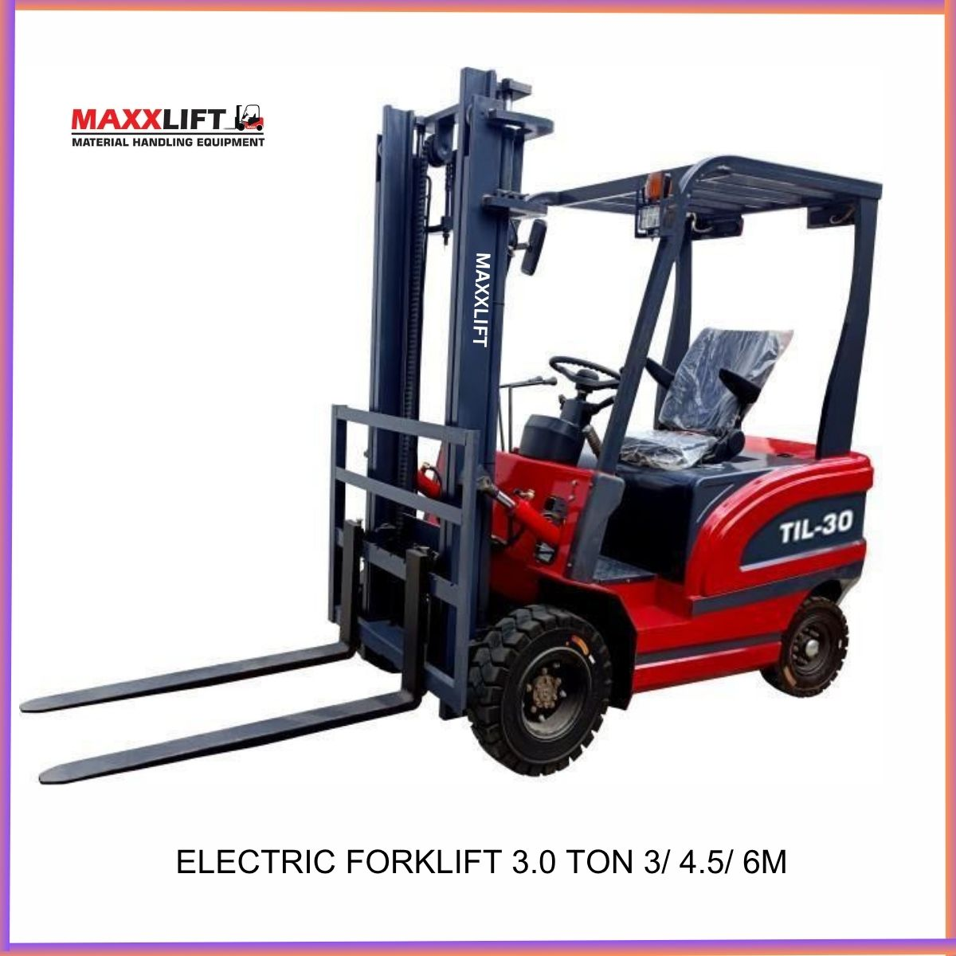

Product Video
Add a short demonstration video link
YouTube – https://www.youtube.com/watch?v=XXXXXXX
Instagram – https://www.instagram.com/reel/XXXXXXX

Machine Description
The 3 Ton Electric Forklift provides smooth hydraulic lifting with a strong 11 kW AC lift motor and a 7.5 kW AC travel motor.
Its high-strength steel frame, double oil-cylinder mast, and thickened axle design ensure durability and stability under load.
The machine runs on a 60 V 650 Ah battery offering 7 to 8 hours of continuous working time.
Advanced hydraulic power steering, reinforced Class A solid tyres, and an efficient drive axle make it ideal for heavy-duty industrial tasks.
It is suitable for both indoor and outdoor applications where high lifting capacity and reliability are essential.
Parameter | Detail | Parameter | Detail
Model No. | MAXX-3.0 Ton | Rated Load | 3000 kg
Travel Motor | 7.5 kW AC Super Quiet | Lift Motor | 11 kW AC First Stage Gear Pump
Drive Axle | 1: 41 Ratio Cast Square Steel Bridge Wear Resistant | Steering System | Hydraulic Power Assist Microcomputer Control
Door Frame | Double Oil Cylinder Special Steel for Forklift | Steering Rear Axle | Thickened Double Steel Plate Bridge
Battery Capacity | 650 Ah | Output Voltage | 60 V
Battery Quantity | 10 Pieces Lead Acid Type | Battery Life | 7 to 8 Hours
Charging Voltage | 220 V | Charging Time | 5 to 6 Hours Intelligent Auto Stop
Raised Height | 3 m (Customizable 4.5 m and 6 m available) | Fork Length | 1.07 m Forged Anti-Wear Steel
Body Size | 2.5 × 1.2 × 2.15 m (Excluding Fork Length) | Machine Height | 2.15 m (Can Be Lowered)
Self-Weight | 3600 kg | Counter Weight | Pure Iron
Tyres (Class A Solid) | Front 23-9-10 Rear 18-7-8 Reinforced Type | Car Paint | Advanced Automotive Paint
Braking Method | Hand Brake | Drive Type | Electric Battery Powered

Where It Is Used
- Heavy warehouses and logistics hubs
- Industrial manufacturing plants
- Ports and dock yards
- Automotive and engineering workshops
- Construction material yards
- Packaging and loading units
- Steel and machinery industries

Services and Support
MAXXLIFT provides complete after-sales support including installation, operator training, preventive maintenance and on-site service within 24 to 48 hours.
Genuine spare parts are available through our branches in Sonipat, Gujrat, Kundli, and Bhiwadi for minimum downtime.

Warranty
Standard warranty 12 months from date of delivery covering major electrical and mechanical components under normal working conditions.
Extended warranty and annual maintenance contracts available on request

Delivery Time
Normal delivery 2 to 3 weeks after order confirmation and advance payment.
Immediate dispatch possible for ready stock machines.

Delivery Locations
MAXXLIFT supplies across India including Delhi NCR, Haryana, Punjab, Rajasthan, Uttar Pradesh, Gujarat, Maharashtra and other industrial regions.

Why Choose MAXXLIFT
- Indian manufacturing and engineering expertise
- Strong steel structure for long service life
- High performance AC motor system
- Smooth and silent operation with zero emission
- Easy maintenance and quick service support
- Trusted by leading industries nationwide

Contact Details
MAXXLIFT MOTORS PRIVATE LIMITED
Main Highway NH 44 GT Karnal Road Kundli Sonipat Opposite KFC Restaurant Haryana
Mobile 9811679096 7678272743 9950921878 9218058170Website www.maxxlift.in

Electric Stacker Reach Machine – Model-Maxx-Reach Stacker 2.0 Ton

Overview
The MAXXLIFT Electric Stacker Reach Machine is designed for precise lifting and stacking operations inside warehouses and factories.
It is compact powerful and energy efficient allowing easy movement in narrow aisles.
The side drive design improves balance and visibility for the operator making it ideal for modern warehouse logistics and pallet handling.

PRODUCT PHOTO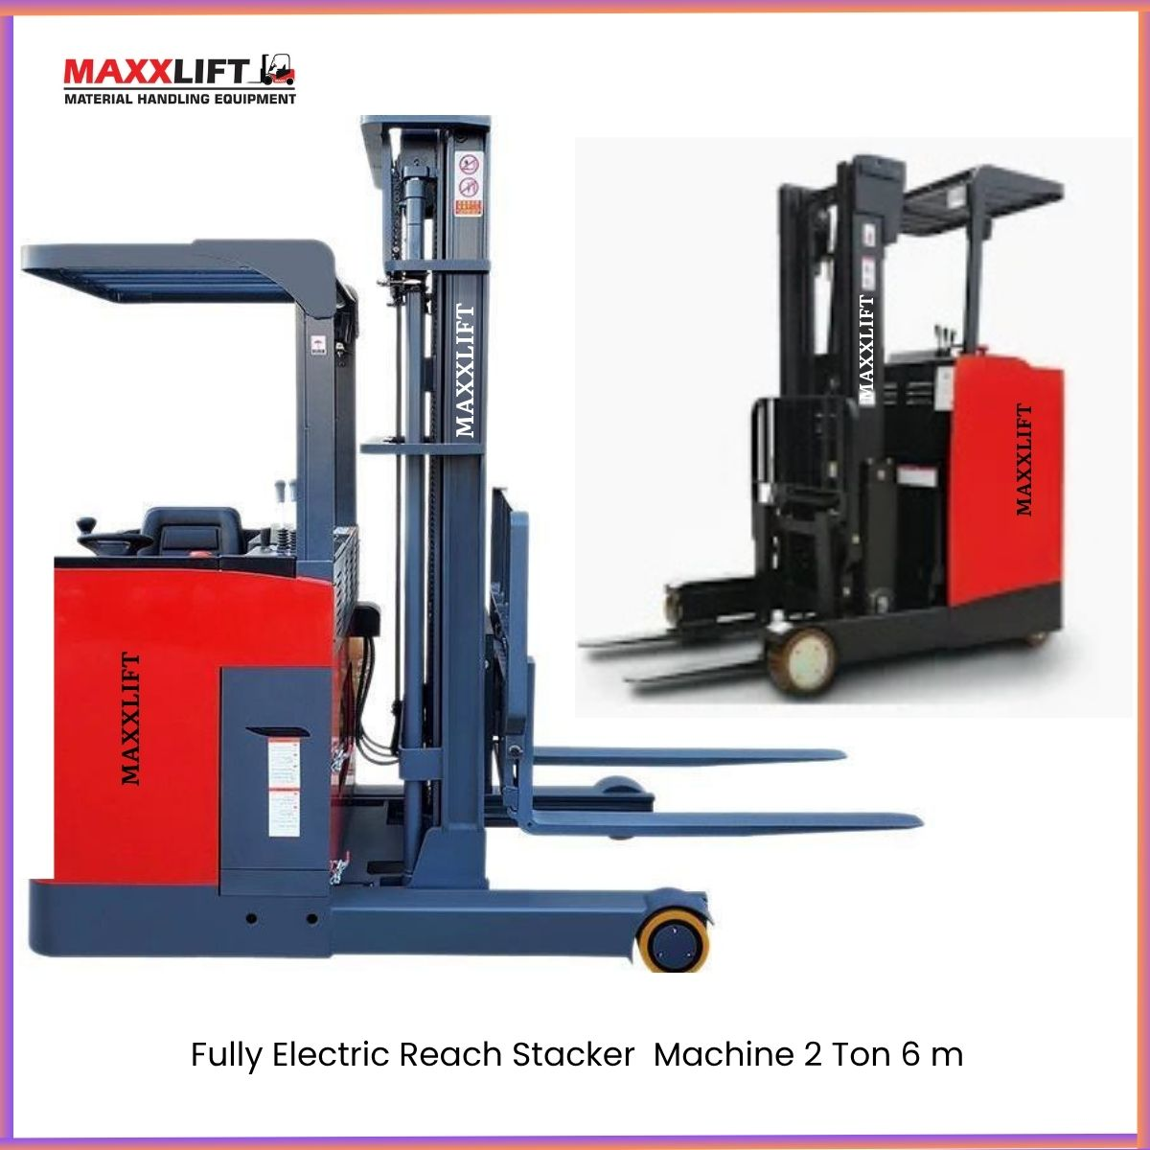

Product Video
YouTube – https://www.youtube.com/watch?v=XXXXXXX
Instagram – https://www.instagram.com/reel/XXXXXXX

Machine Description
This electric stacker is built for efficient warehouse stacking up to 5.5 meters height.
The operator can drive it from the side position providing excellent control and reduced turning radius.
Its electric drive system offers quiet performance zero emission and low running cost.
The strong frame and forged forks ensure safe operation with loads up to 2 Ton.
Parameter | Detail | Parameter | Detail
Model No. | MAXX-WH Electric Forklift | Application | Warehouse Material Handling
Type | Longitudinal Stacker | Power Source | Battery Electric
Lifting Capacity | 2000 kg (2 Ton) | Lift Height | 5.5 m
Fork Length | 1070 mm | Fork Width | 550 mm (adjustable)
Drive Type | Electric Reach Type | Operating Position | Side Drive Compact Design
Battery Type | Lead Acid or Optional Lithium | Motor Type | AC Electric Motor
Steering System | Hydraulic Power Assist | Brake System | Electromagnetic with Parking Brake
Tyres | Polyurethane non-marking | Working Time | 6 to 8 Hours per Charge
Charging Voltage | 220 V | Charging Time | 4 to 5 Hours
Frame Material | Heavy Duty Steel Construction | Paint Finish | Red and Black

Where It Is Used
- Warehouses and distribution centres
- Manufacturing plants and packaging areas
- Cold storage and logistics units
- Retail storage and pallet handling systems
- Factories requiring high reach stacking in narrow aisles

Services and Support
MAXXLIFT provides full-service installation and operator training.
Preventive maintenance and breakdown support available within 24 to 48 hours.
Spare parts and accessories are available at Sonipat Gurugram Kundli and Bhiwadi branches.

Warranty
Standard warranty 12 months from date of delivery for major mechanical and electrical components.
Extended warranty and annual maintenance contract available upon request.

Delivery Time
Delivery period 2 to 3 weeks after order confirmation and advance payment.
Faster delivery possible for ready stock models.

Delivery Locations
We deliver across India including Delhi NCR Haryana Punjab Rajasthan Uttar Pradesh Gujarat Maharashtra and all major industrial locations.

Why Choose MAXXLIFT
- Compact side-drive design for easy operation
- Heavy duty steel mast and frame
- Smooth hydraulic lifting up to 5.5 meters
- Zero emission low noise operation
- Long battery life with efficient AC motor
- Reliable after-sales support across India

Contact Details
MAXXLIFT MOTORS PRIVATE LIMITED
Main Highway NH 44 GT Karnal Road Kundli Sonipat Opposite KFC Restaurant Haryana
Mobile 9811679096 7678272743 9950921878 9218058170
Website www.maxxlift.in

Model-Maxx-Electric Forklift 3 Ton with Paper Roll Clamps Attachment (PRC) (For 2 Ton and 3 Ton Electric Forklifts)

Faster Roll Handling
Excellent visibility through and around clamp
Continuous 360-degree rotation

Excellent Durability
Unitized construction in the arm and frame provides structural integrity and delivers outstanding durability
Proven strong rotator drive train
Pivot bushings are lube free and provide superior service life
DESCRIPTION
Paper Roll Clamps Attachment is designed for high performance in paper handling operations.
It ensures excellent visibility for the operator and reduces paper roll damage.
This equipment allows continuous 360-degree rotation for faster material flow.
The structure uses heavy duty steel with a thin arm profile to handle paper rolls efficiently and permit close stacking.
It is widely used in printing packaging and corrugation industries where fast movement and secure grip are essential
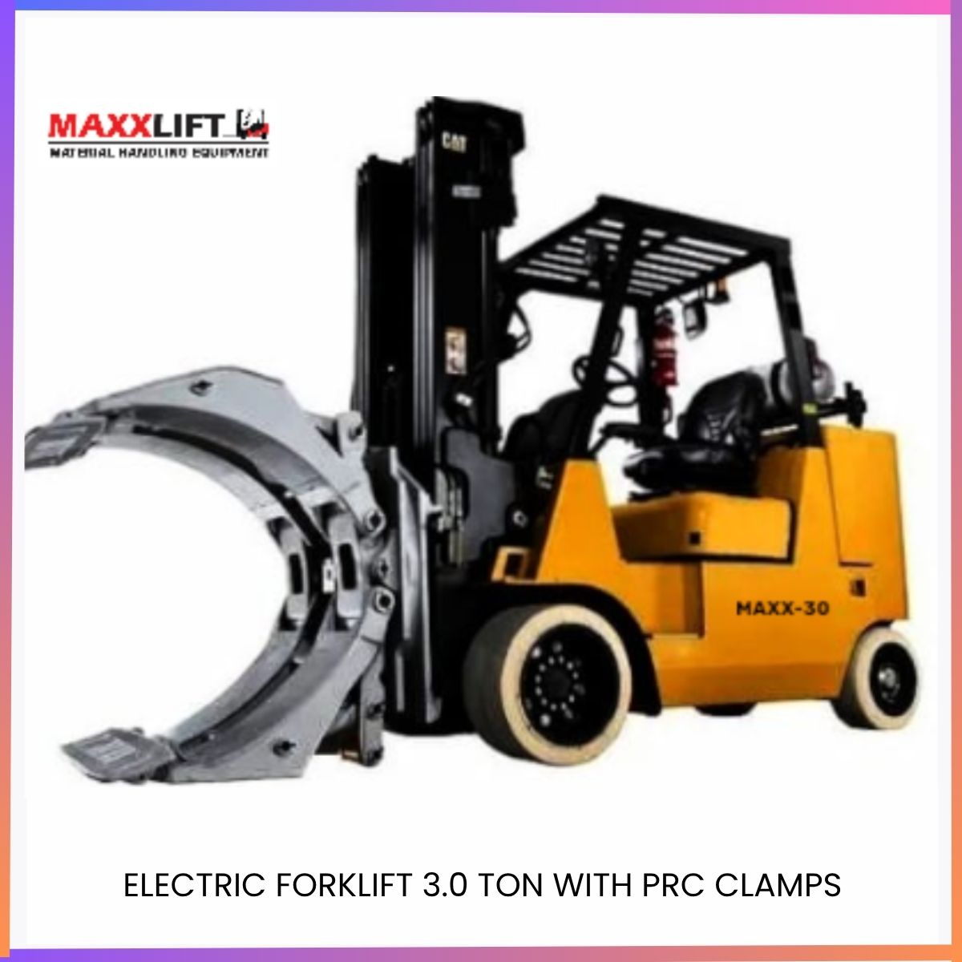

FEATURES

Reduce Roll Damage
- Proven contact pad shape and surface holds rolls securely
- Thin arm profile and smooth contour allow easy roll breakout
- Short arm design maintains uniform grip across all roll diameters

Faster Roll Handling
- Excellent operator visibility through and around clamp
- Continuous 360-degree rotation for quick loading and unloading

Excellent Durability
- Unitized arm and frame provide high structural strength
- Proven rotator drive train ensures long service life
- Lube free pivot bushings reduce maintenance and downtime
Parameter | Detail | Parameter | Detail
Model Name | MAXX-PRC 22-24 | Equipment Weight | 680 kg
Opening Range | 300 mm – 1300 mm | Max Load Capacity | 2000 kg
Maximum Working Pressure | 160 bars | Suitable For | 3 Ton Electric Forklift
Rotation | 360 degrees continuous | Application | Paper Roll Handling
Frame Type | Double Arm Structure | Drive Type | Hydraulic
Material | High Strength Alloy Steel | Finish | Powder Coated MAXXLIFT Red
Mounting | Class II and III | Industry Use | Paper and Packaging Units

APPLICATION AREAS
- Paper roll warehouses
- Corrugated box manufacturing
- Printing and packaging industries
- Newsprint and publishing units
- Logistic and storage centres

SERVICES AND SUPPORT
MAXXLIFT offers installation and operator training support for all forklift attachments.
On site service available within 24 to 48 hours.
Spare parts and hydraulic kits stocked at Sonipat Gurugram Kundli and Bhiwadi branches.

WARRANTY
Standard warranty 12 months from the date of delivery covering hydraulic and structural parts.
Extended warranty and annual maintenance plans available on request.

DELIVERY TIME
Standard delivery 2 to 3 weeks after order confirmation and advance payment.
Immediate dispatch available for ready stock attachments.

DELIVERY LOCATIONS
Available PAN India including Delhi NCR Haryana Punjab Rajasthan Uttar Pradesh Gujarat Maharashtra and other industrial areas.

WHY MAXXLIFT
- Proven design for high performance and long life
- Continuous rotation with precise control
- Heavy duty builds for industrial use
- Easy installation on 2 Ton and 3 Ton Electric Forklifts
- Reliable after sales service and support network across Indi

CONTACT DETAILS
MAXXLIFT MOTORS PRIVATE LIMITED
Main Highway NH 44 GT Karnal Road Kundli Sonipat Opposite KFC Restaurant Haryana
Mobile 9811679096 7678272743 9950921878 9218058170
Website www.maxxlift.in

Model-Maxx-3.5 Ton Rough Terrain Diesel Forklift

Overview
The MAXXLIFT 3.5 Ton Diesel Forklift is designed for outdoor rough-terrain applications requiring high power durability and lifting stability.
It delivers strong performance in construction sites brick plants material yards and loading areas with uneven ground.
Equipped with a powerful diesel engine and wide-base pneumatic tyres this forklift ensures smooth travel excellent traction and long operating life.

Product Photos
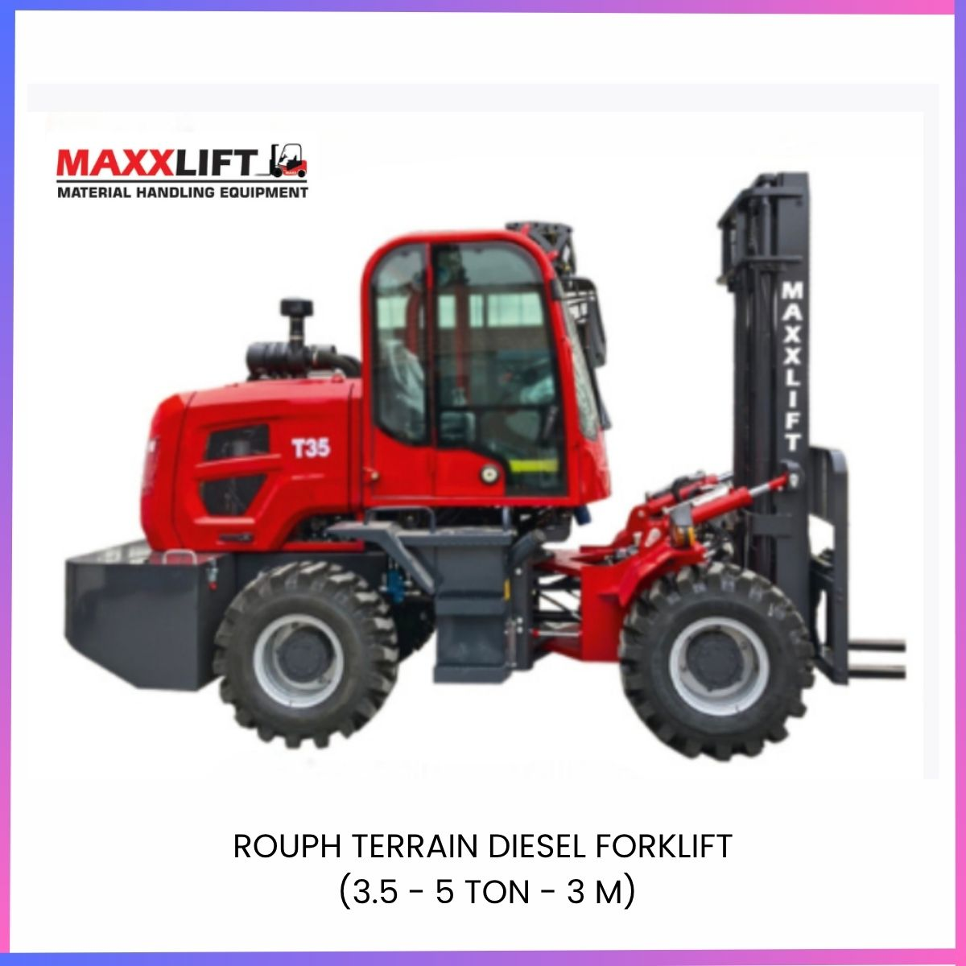

Product Video
link:
YouTube – https://www.youtube.com/watch?v=XXXXXXX
Instagram – https://www.instagram.com/reel/XXXXXXX

Machine Description
This rough-terrain forklift is powered by a QUANCHAI 490 diesel engine producing 36.8 kW.
It features a lifting capacity of 3.5 ton and a height of 3 meters.
The strong chassis weighted wheel bridge and large tyres provide high stability on rough surfaces.
Ideal for outdoor sites and heavy construction material movement.
Parameter | Detail | Parameter | Detail
Model | MAXX T-35 T | Engine | QUANCHAI 490
Power Output | 36.8 kW | Rated Load | 3 Ton
Lifting Height | 3 m | Fork Length | 1220 mm
Transmission | JINLITE 265 Gearbox | Axle Type | Weighted Wheel bridge
Tyres | 20.5 / 70 – 16 Pneumatic | Weight | 4390 kg
Mini Turning Radius | 4700 mm | Outline Dimension | 4150 × 1800 × 2450 mm
Fuel Type | Diesel | Drive Type | 4 Wheel Drive
Paint Finish | MAXXLIFT Red Automotive Paint | Cabin | Enclosed Driver Cabin
Application | Outdoor and Rough Terrain | Country of Make | India

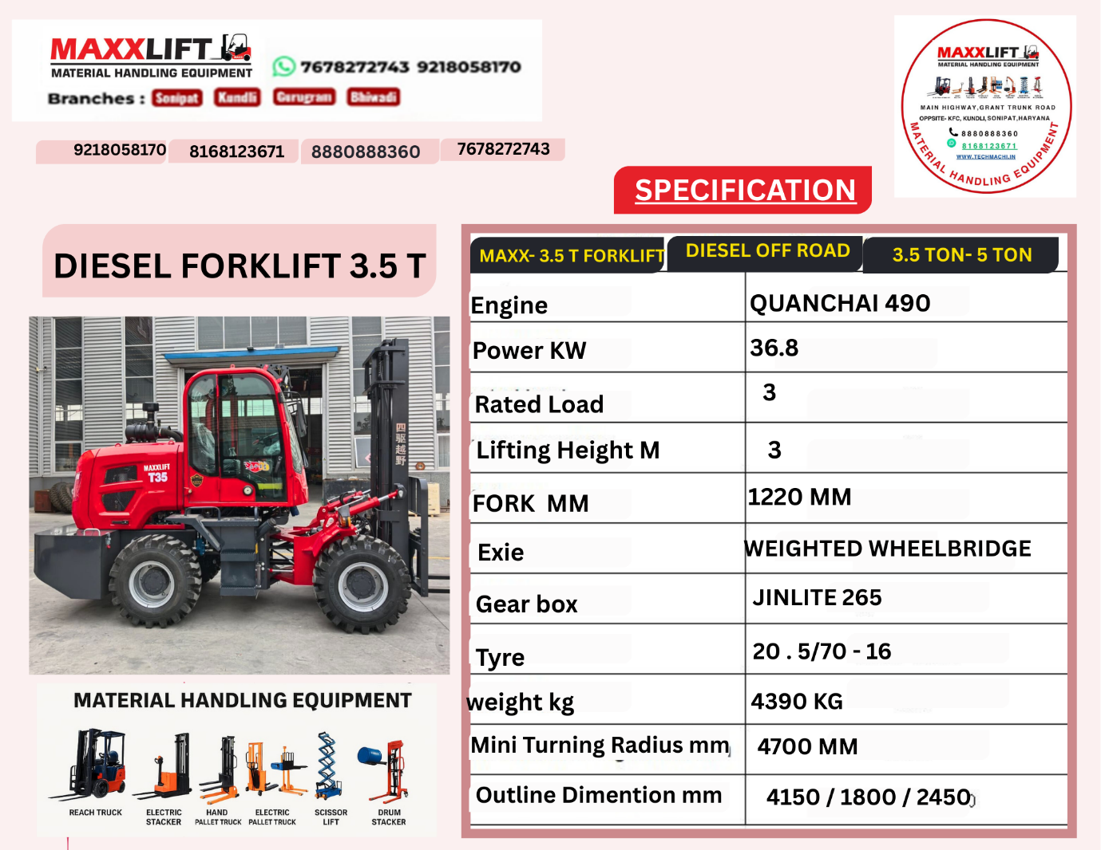

Services and Support
MAXXLIFT offers full installation operator training and service support.
Maintenance and spare parts are available through branches in Sonipat Gurugram Kundli and Bhiwadi.
On-site service within 24 to 48 hours for quick response.

Applications
- Construction material loading and transport
- Brick kiln and stone industry
- Factory yards and outdoor storage areas
- Industrial sites and ports
- Agricultural produce handling
- Logistics centres with uneven flooring

Warranty
Standard warranty 12 months from the date of delivery covering major mechanical components.
Extended warranty and annual maintenance contracts are available upon request.

Delivery
Delivery period 2 to 3 weeks after order confirmation and advance payment.
Immediate dispatch available for ready stock models.

Delivery Locations
Available PAN India including Delhi NCR Haryana Punjab Rajasthan Uttar Pradesh Gujarat Maharashtra and other industrial regions.

Why Choose MAXXLIFT
- Heavy-duty diesel forklift engineered for Indian conditions
- High stability on rough terrain and uneven surfaces
- Reliable QUANCHAI engine with strong gearbox
- Low maintenance long service life
- Strong after-sales and service network across India

Contact Details
MAXXLIFT MOTORS PRIVATE LIMITED
Main Highway NH 44 GT Karnal Road Kundli Sonipat Opposite KFC Restaurant Haryana
Mobile 9811679096 7678272743 9950921878 9218058170
Website www.maxxlift.in

Self-Loading & Unloading Electric Stacker Fully Automatic

Model-Maxx-self Loading 1Ton1.6 M

Overview
The MAXXLIFT Self-Loading and Unloading Electric Stacker is a fully automatic lifting solution designed for easy pallet handling and vehicle loading without the need for a separate dock or ramp.
It combines the functionality of a stacker and pallet truck making it ideal for compact warehouses manufacturing units and logistics operations.
Its smart drive system and self-lifting platform allow the machine to lift itself along with the load safely and efficiently.

Product Photos
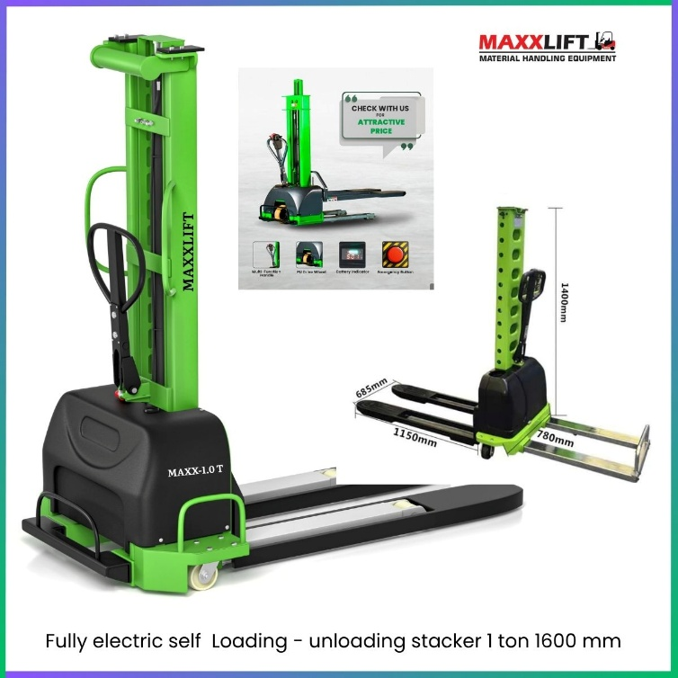

Product Video

YouTube – https://www.youtube.com/watch?v=XXXXXX
Instagram – https://www.instagram.com/reel/XXXXXX

Machine Description
This model is a compact fully automatic electric stacker with self-lifting capability up to 3 m height and 1 Ton capacity.
It can lift itself onto trucks or platforms without a ramp saving time and manpower.
The advanced drive motor and battery system ensure smooth operation silent movement and zero emission.
Strong construction with solid forks ensures durability and safety during heavy-duty work.
Parameter | Detail | Parameter | Detail
Model No. | MAXX-SL-10 | Rated Capacity | 1000 kg (1 Ton)
Lift Height | 1600 mm | Fork Length | 1195 mm
Fork Width | 550 mm (Adjustable) | Type | Self-Loading / Unloading Fully Automatic
Drive Motor | 1.5 kW AC Electric | Lift Motor | 2.2 kW Hydraulic Power Pack
Battery Voltage | 24 V DC | Battery Capacity | 210 Ah Lead-Acid (Optional Lithium)
Charging Voltage | 220 V | Charging Time | 5 Hours (Intelligent Auto Stop)
Travel Speed | 4–5 km/h | Working Hours | 6–8 Hours per Charge
Mast Type | Double Stage Heavy-Duty Steel | Ground Clearance | 40 mm
Turning Radius | 1450 mm | Brake System | Electromagnetic with Parking Brake
Tyres | Polyurethane non-marking | Paint Finish | MAXXLIFT Green and Black Powder Coat
Parameter | Detail | Parameter | Detail
Type | Fully Electric Self-Loading Stacker | Model | PNXFESLS-0513
Capacity | 500 kg | Load Centre Distance | 500 mm
Fork Outer Spacing | 685 mm | Fork Length | 1195 mm
Operation Type | Walking Type | Fork Lift Height | 1300 mm
Fork Starting Height | 81 mm | Wheel Base | 974 mm
Vehicle Length | 1650 mm | Body Width | 658 mm
Body Thickness | 409 mm | Front Track | 518 mm
Single Fork Width | 253 mm | Minimum Turning Radius | 1173 mm
Turtle Speed | 0.5 km per hour | Motor | DC 0.6 kW
Lift Motor | DC 2.2 kW | Battery Type | Lithium 48 V
Battery Capacity Dry | 15 Ah | Battery Weight | 382 KG
 |  | Charging Voltage | 220 V

Key Features
- Fully automatic operation with electric lift and travel
- Self-loading and unloading without ramp or dock
- Compact design for narrow aisle movement
- Strong mast with 3 m lift height
- Low noise zero emission operation
- Easy-to-use control handle with speed adjustment
- Maintenance-free drive system
Where It Is Used
- Warehouse and godown operations
- Vehicle loading and unloading
- Manufacturing units and assembly lines
- Small logistic centres and retail storage
- Factories with limited space or no dock facility

Services and Support
MAXXLIFT provides full installation and training at site.
Preventive maintenance and on-site service available within 24 to 48 hours.
Spare parts and batteries available at Sonipat Gurugram Kundli and Bhiwadi branches.
Warranty
Standard warranty 12 months from delivery covering electrical and mechanical systems.
Extended warranty and AMC available on request.
Delivery Time
Normal delivery 2 to 3 weeks after order confirmation and advance payment.
Immediate dispatch available for ready stock units.
Delivery Locations
PAN India coverage including Delhi NCR Haryana Punjab Rajasthan Uttar Pradesh Gujarat and Maharashtra.
Why Choose MAXXLIFT
- Compact multifunction design
- Time-saving self-loading mechanism
- Zero emission and low maintenance
- High reliability and operator safety
- Proven after-sales support network
Contact Details
MAXXLIFT MOTORS PRIVATE LIMITED
Main Highway NH 44 GT Karnal Road Kundli Sonipat Opposite KFC Restaurant Haryana
Mobile 9811679096 7678272743 9950921878 9218058170
Website www.maxxlift.in

Fully Electric Walkie Stacker – Model -Maxx-FEWS 2Ton/3M

Overview
The MAXXLIFT Fully Electric Walkie Stacker is a powerful and efficient lifting machine for warehouse and factory operations.
It offers smooth and quiet electric performance with high lifting height and compact design.
This 2 Ton model is suitable for material stacking, pallet movement, and medium-height warehouse applications up to 3 meters.
Product Description
The 2 Ton Fully Electric Walkie Stacker is designed for easy operation, minimal maintenance, and maximum efficiency.
It features a strong steel frame, energy-efficient motor, and ergonomic handle for precise control.
The machine is ideal for narrow aisles and smooth surfaces, offering safe and stable lifting for pallets and materials in industrial environments.
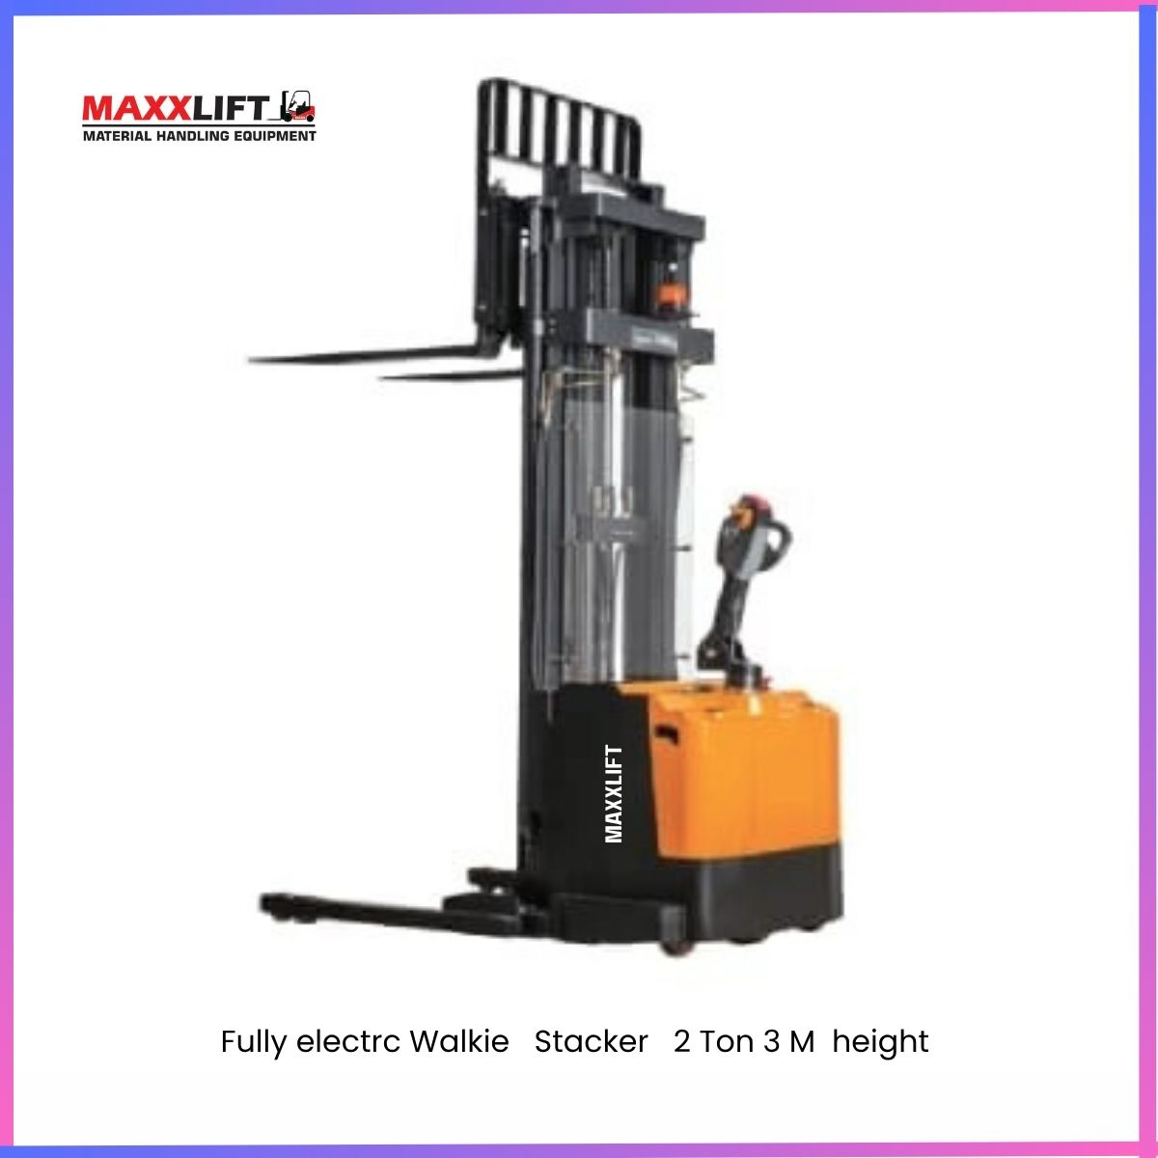
Product Video

YouTube – https://www.youtube.com/watch?v=XXXXXX
Instagram – https://www.instagram.com/reel/XXXXXX

Technical Specifications

Parameter | Detail | Parameter | Detail
Model Name | MAXX-FEWS -2 T | Rated Load Capacity | 2000 kg (2 Ton)
Lifting Height | 3000 mm | Minimum Gantry Height | 1805 mm
Maximum Raising Height | 3010 mm | Minimum Fork Height | 90 mm
Fork Width | 800 mm | Fork Outer Width | 680 mm – 330 mm
Load Centre | 450 mm | Fork Size | 1150 × 150 × 6 mm
Load Bearing Wheels | 74 × 70 mm | Steering Wheels | 120 × 50 mm
Drive Motor | 1.5 kW | Operation Type | Walk-Behind Fully Electric
Power Supply | 24 V Battery | Battery Charging Voltage | 12V 65Ah*2
Turning Radius | 1450 mm | Working Hours | 6–8 hours per charge
Travel Speed | 4–5 km per hour | Paint Finish | MAXXLIFT Red and Black Automotive Coating

Key Features
- Fully electric operation with high efficiency
- Compact design ideal for narrow aisles
- Lifts up to 3 meters safely and smoothly
- Robust steel mast for long life and stability
- Maintenance-free battery with easy charging
- Low noise zero emission operation
- Ergonomic control handle for comfortable use

Applications
- Warehouses and storage facilities
- Packaging and logistics centres
- Manufacturing and assembly plants
- Loading and unloading zones
- Industrial and commercial stockrooms

Services and Support
MAXXLIFT provides complete after-sales support including installation, training, and preventive maintenance.
On-site service is available within 24–48 hours.
Genuine spare parts are stocked at Sonipat, Gurugram, Kundli, and Bhiwadi branches.

Warranty
Standard warranty 12 months from the date of delivery covering electrical and mechanical components under normal use.
Extended warranty and annual maintenance contracts available on request.

Delivery Time
Normal delivery 2–3 weeks after order confirmation and advance payment.
Immediate delivery available for ready stock units.

Delivery Locations
MAXXLIFT supplies and services across India including Delhi NCR, Haryana, Punjab, Rajasthan, Uttar Pradesh, Gujarat, and Maharashtra.

Why Choose MAXXLIFT
- Indian engineering and manufacturing excellence
- High performance fully electric stackers
- Reliable design with long service life
- Quick service support and easy spare availability
- Trusted by industries nationwide

Contact Details
MAXXLIFT MOTORS PRIVATE LIMITED
Main Highway NH 44 GT Karnal Road Kundli Sonipat Opposite KFC Restaurant Haryana
Mobile 9811679096 7678272743 9950921878 9218058170
Website www.maxxlift.in

Fully Electric Pallet Stacker – Model Maxx-FEPS-2T

Overview
The MAXXLIFT 2 Ton Fully Electric Pallet Stacker is a high-performance battery-operated lifting machine designed for safe and efficient material handling.
It combines powerful electric drive, stable mast design, and intelligent controls to provide smooth operation, long working hours, and zero-emission performance.
Ideal for medium to large warehouses, logistics hubs, and manufacturing facilities, this machine ensures precision lifting up to 3 meters with minimal human effort.

Product Description
This model features a robust 24V 2.2 kW motor and high-capacity 240 Ah battery providing reliable performance for continuous operations.
Its fully automatic lifting and lowering system is perfect for pallet stacking and loading work.
Equipped with a reinforced mast and ergonomic tiller handle, it provides excellent visibility and control.
The compact structure allows easy movement in narrow aisles, ensuring productivity and safety in industrial environments.
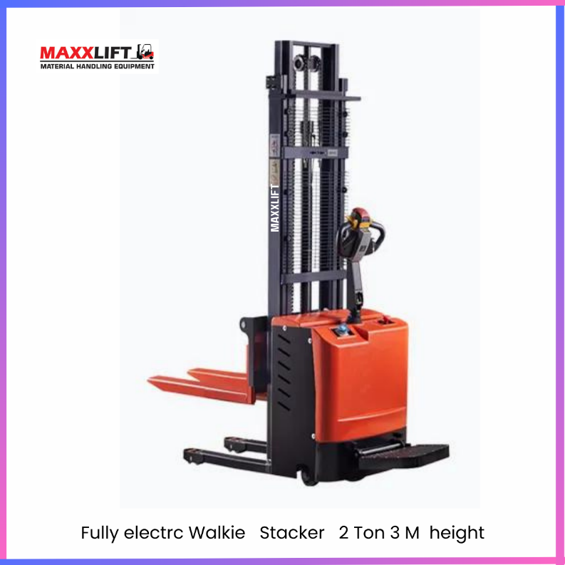

PRODUCT VIDEO

YouTube – https://www.youtube.com/watch?v=XXXXXX
Instagram – https://www.instagram.com/reel/XXXXXX

Technical Specifications
Parameter | Detail | Parameter | Detail
Model No. | TIL-2 Ton Fully Electric Pallet Stacker | Type | Battery Operated Fully Automatic
Rated Load Capacity | 2000 kg (2 Ton) | Max Lifting Height | 2000 mm
Min Fork Height from Ground | 85 mm | Door Frame Height (Lowered) | 2000 mm
Fork Width (Outside / Inside) | 640 mm | Fork Length | 1150 mm
Overall Vehicle Length | 2500 mm | Overall Vehicle Width | 800 mm
Front Wheel Dimension | 74 × 70 mm | Load Centre | 800 mm
Battery Voltage | 24 V | Battery Capacity | 240 Ah
Charger Type | 12V65 AH | Motor Power | 24 V / 2.2 kW
Travel Speed (Loaded / Unloaded) | 4–5 km per hour | Working Time | 6–8 Hours per Charge
Mast Type | Double Stage Steel Mast | Turning Radius | 1450 mm
Brake Type | Electromagnetic with Parking Brake | Finish | Orange and Black Powder Coating

Key Features
- Fully electric operation for lifting and travel
- Compact design for easy manoeuvrability in narrow spaces
- Strong mast and stable base structure for safety
- Zero emission and low maintenance cost
- Long battery backup with intelligent charger
- Heavy-duty steel forks for stable lifting
- Ergonomic tiller handle with control switches

Applications
- Warehouses and logistics centres
- Manufacturing and assembly units
- Loading and unloading bays
- Packaging and storage facilities
- Industrial plants and distribution hubs
Services and Support
MAXXLIFT provides full installation, operator training, and after-sales maintenance support.
On-site service available within 24–48 hours.
Spare parts and technical assistance offered through Sonipat, Gurugram, Kundli, and Bhiwadi branches.
Warranty
Standard warranty 12 months from delivery covering major electrical and mechanical components under normal working conditions.
Extended warranty and AMC available upon request.
Delivery Time
Standard delivery within 2–3 weeks after order confirmation and advance payment.
Faster shipment available for ready stock models.
Delivery Locations
Nationwide delivery including Delhi NCR, Haryana, Punjab, Rajasthan, Uttar Pradesh, Gujarat, and Maharashtra.
Why Choose MAXXLIFT
- Indian manufacturing and engineering excellence
- Energy-efficient design for low running cost
- Long service life with sturdy construction
- Full technical support and spare part availability
- Trusted brand for electric forklifts and stackers

Contact Details
MAXXLIFT MOTORS PRIVATE LIMITED
Main Highway NH 44 GT Karnal Road Kundli Sonipat Opposite KFC Restaurant Haryana
Mobile 9811679096 ,7678272743 ,9950921878 ,9218058170
Website www.maxxlift.in

Electric Stacker Model MAXX-2T-4.5M Fully Electric Pallet Stacker

Overview
The MAXXLIFT 2 Ton 4.5 Meter Fully Electric Pallet Stacker is a heavy-duty lifting solution designed for high-rise warehouse and industrial operations.
It offers smooth fully electric lifting and travel with zero emission performance.
Its advanced MOS stepless speed control system and ergonomic design ensure operator comfort, precision handling, and long battery life.
This stacker is ideal for tall rack storage, heavy pallet handling, and intensive warehouse applications.

Machine Description
The TIL-2T-4.5M Electric Stacker is engineered with a powerful 2.2 kW lift motor and 1.2 kW drive motor for consistent lifting performance.
Its reinforced steel mast supports 4.5-meter height with stable load balance.
The electromagnetic braking system ensures safety on ramps while the polyurethane wheels allow smooth movement on warehouse floors.
Compact body and strong chassis design provide high stability and manoeuvrability in tight aisles.
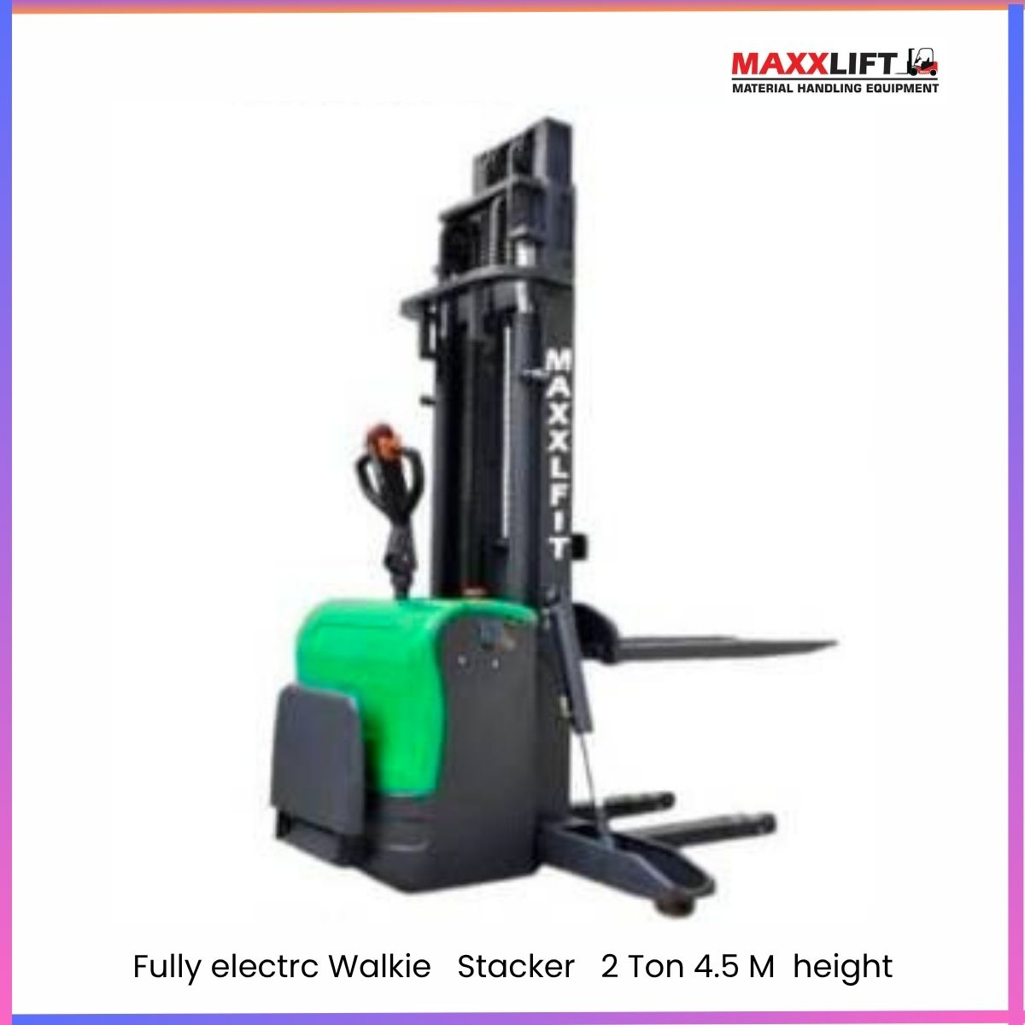
PRODUCT VIDEO - INSERT LINK FROM -INSTAGRAM / YOUTUBE
Technical Specifications
Parameter | Detail | Parameter | Detail
Model No. | TIL-2T-4.5M Fully Electric Pallet Stacker | Rated Lifting Weight | 2000 kg
Door Frame Lifting Height | 4500 mm | Load Centre Distance | 500 mm
Height of Cargo Fork After Descent | 90 mm | Turning Radius | 1580 mm
Minimum Channel Requirement | 1850 mm | Door Still Height | 2580 mm
Body Length (Pedal Stacking) | 1980 mm | Total Body Width | 1150 mm
Fork Outer Width | 720 mm | Fork Width (Cargo Fork) | 400 mm
Standard Fork Size (L×W×H) | 1000 × 160 × 50 mm | Minimum Width | 320 mm
Lift Speed (Full Load / No Load) | 85 / 110 mm per second | Driving Speed (Full / Empty Load) | 4 / 6 km per hour
Maximum Ramp Level (Full / No Load) | 5% / 7% | Tyre Type | PU / PU
Bearing Wheel Size | 80 × 70 mm | Drive Wheel Size | 250 × 80 mm
Balancing Wheel Size | 120 × 50 mm | Control Form | Station Drive Type
Speed Regulation Mode | MOS Stepless Speed Control | Brake Mode | Electromagnetic Braking
Battery Operating Time | 4–5 Hours Continuous | Battery Voltage | 24 V (250 × 80 mm Battery Cell)
Lift Motor | 2.2 kW | Drive Motor | 1.2 kW
Controller | Coty us 1203 | Hydraulic Oil | 46#
Operating Weight | 1050 kg | Paint Finish | Green and Black Powder Coating

Key Features
- Fully electric lifting and travel
- 4.5 m lift height for high-rack warehousing
- Advanced MOS stepless speed control system
- Compact turning radius for narrow aisles
- Electromagnetic braking for safe operation
- Energy-efficient motors with high torque output
- Durable PU wheels for smooth indoor use
- Robust chassis and reinforced mast for stability
-Applications
- Multi-level warehouse operations
- Industrial plants and manufacturing lines
- Logistics and packaging centres
- Distribution hubs and retail warehouses
- Storage yards with tall pallet racks
Services and Support
MAXXLIFT provides full installation, operator training, and preventive maintenance.
On-site service available within 24–48 hours.
Spare parts and technical support available through Sonipat, Gurugram, Kundli, and Bhiwadi branches.
Warranty
Standard warranty 12 months from the date of delivery covering electrical and mechanical components.
Extended warranty and annual maintenance contract available on request.
Delivery
Standard delivery within 2–3 weeks after order confirmation and advance payment.
Immediate delivery available for ready stock models.
Delivery Locations
MAXXLIFT delivers machines PAN India including Delhi NCR, Haryana, Punjab, Rajasthan, Uttar Pradesh, Gujarat, Maharashtra, and other industrial zones.
Why Choose MAXXLIFT
- Indian design and heavy-duty engineering
- Smooth and silent operation with zero emission
- Long-life battery and reliable performance
- High lift range for industrial warehousing
- Complete service and parts support nationwide

Contact Details
MAXXLIFT MOTORS PRIVATE LIMITED
Main Highway NH-44 GT Karnal Road Kundli Sonipat Opposite KFC Restaurant Haryana
Mobile 9811679096 7678272743 9950921878 9218058170
Website www.maxxlift.in

2 Ton Fully Electric Pallet Stacker – 6 M
Model MAXX-2T-6M Fully Electric Pallet Stacker

Overview
The MAXXLIFT 2 Ton 6 Meter Fully Electric Pallet Stacker is a high-reach battery-operated lifting solution built for tall rack storage and warehouse automation.
It ensures smooth lifting, stable balance, and long operation hours for heavy-duty industrial use.
Powered by advanced MOS stepless speed control and electromagnetic braking, it delivers precision, safety, and quiet operation.
Ideal for warehouses, logistics hubs, and industrial units requiring high vertical reach.

Product Video
YouTube: https://www.youtube.com/watch?v=XXXXXXX
Instagram: https://www.instagram.com/reel/XXXXXXX
Machine Description
This stacker is engineered for superior performance and reliability with 2.2 kW lift and 1.2 kW drive motors.
The reinforced mast supports up to 6 meters of lift height with excellent structural rigidity.
Its electromagnetic braking system ensures safety on ramps and during descent.
PU wheels provide smooth movement and stability on warehouse floors, while the ergonomic drive handle offers precision steering.
Designed for indoor logistics, it maximizes efficiency with zero emissions and low running costs. Signed for indoor logistics, it maximizes efficiency with zero emissions and low running costs.

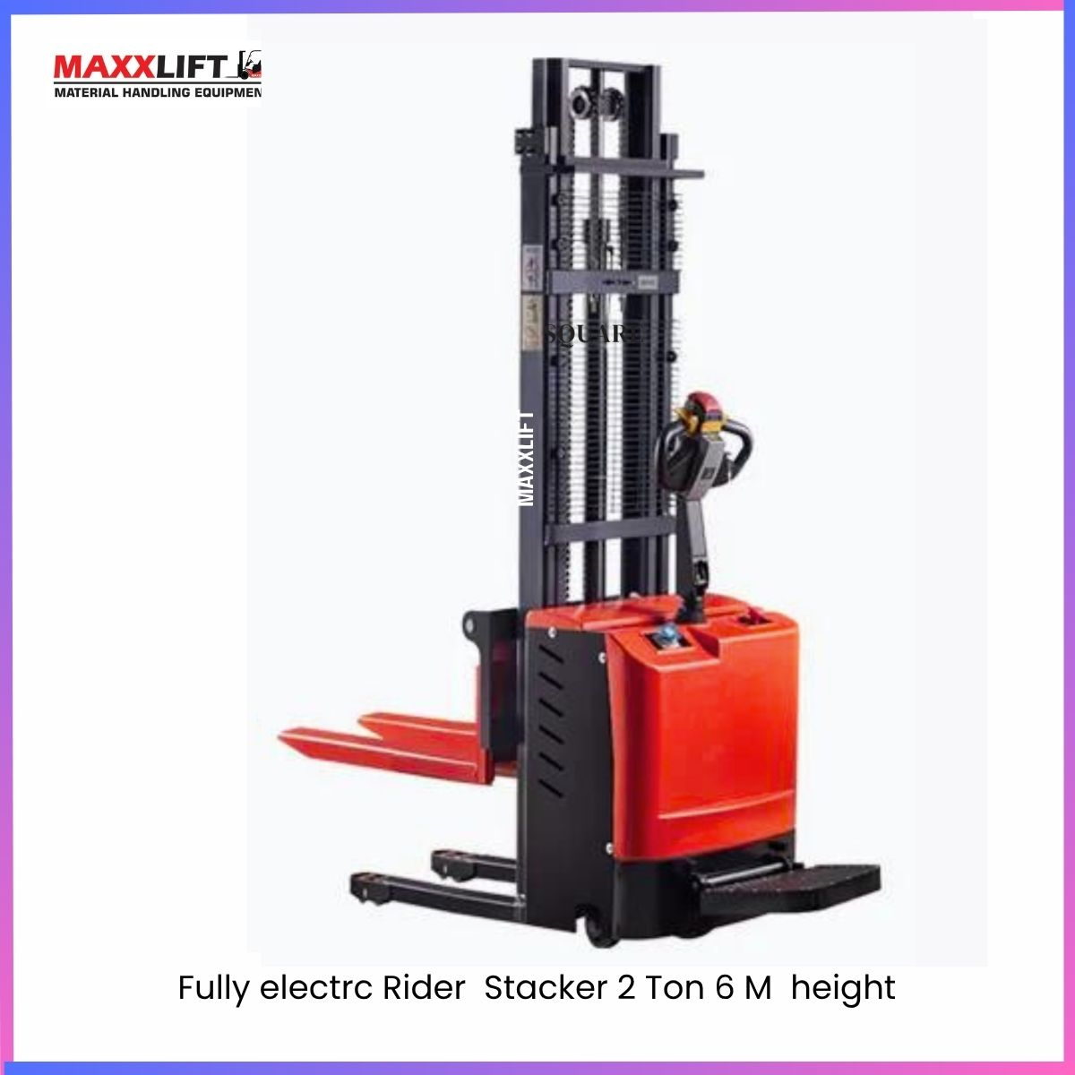
PRODUCT VIDEO - INSERT LINK FROM -INSTAGRAM / YOUTUBE
Product Specifications
Parameter | Detail | Parameter | Detail
Model No. | Maxx-2T-6M Fully Electric Pallet Stacker | Rated Lifting Weight | 2000 kg
Door Frame Lifting Height | 6000 mm | Load Centre Distance | 500 mm
Height of Cargo Fork After Descent | 90 mm | Turning Radius | 1580 mm
Minimum Channel Requirement | 1850 mm | Door Still Height | 2580 mm
Body Length (Pedal Stacking) | 1980 mm | Total Body Width | 1150 mm
Fork Outer Width | 720 mm | Cargo Fork Width | 400 mm
Standard Fork Size (L×W×H) | 1000 × 160 × 50 mm | Minimum Width | 320 mm
Lift Speed (Full Load / No Load) | 85 / 110 mm per second | Driving Speed (Full / Empty Load) | 4 / 6 km per hour
Maximum Ramp Level (Full / No Load) | 5% / 7% | Tyre Type | PU / PU
Bearing Wheel Size | 80 × 70 mm | Drive Wheel Size | 250 × 80 mm
Balancing Wheel Size | 120 × 50 mm | Control Form | Station Drive Type
Speed Regulation Mode | MOS Stepless Speed Control System | Brake Mode | Electromagnetic Braking
Battery Operating Time | 4–5 Hours Continuous | Battery Voltage | 24 V
Lift Motor | 2.2 kW | Drive Motor | 1.2 kW
Controller | Coty us 1203 | Hydraulic Oil | 46#
Operating Weight | 1050 kg | Paint Finish | Orange and Black Powder Coating

Key Features
- Fully electric lift and travel
- 6 m lift height for tall warehouse racks
- Powerful 2.2 kW lift and 1.2 kW drive motors
- Advanced MOS speed control system
- Electromagnetic braking for safety
- PU wheels for smooth movement
- Compact turning radius for tight aisles
- Low maintenance and zero emission
Applications
- High-rack warehousing and storage
- Packaging and logistics centres
- Industrial and production lines
- Distribution and cold storage units
- Loading and unloading of heavy pallets
Services and Support
MAXXLIFT offers complete installation, operator training, and preventive maintenance.
On-site service is available within 24 to 48 hours.
Spare parts and technical support are provided through Sonipat, Kundli, and Bhiwadi and upcoming in Gujrat
Warranty
Standard warranty 12 months from delivery covering major electrical and mechanical components under normal working conditions.
Extended warranty and AMC available on request.
Delivery Time
Standard delivery within 2–3 weeks after order confirmation and advance payment.
Immediate dispatch available for in-stock models.
Delivery Locations
PAN India delivery including Delhi NCR, Haryana, Punjab, Rajasthan, Uttar Pradesh, Gujarat, and Maharashtra.
Why Choose MAXXLIFT
- Heavy-duty Indian-built stacker for tall lifting
- Long life with strong mast and base frame
- Smooth operation and high load stability
- Zero emission and low running cost
- Reliable after-sales and service network
Contact Details
MAXXLIFT MOTORS PRIVATE LIMITED
Main Highway NH-44 GT Karnal Road Kundli Sonipat Opposite KFC Restaurant Haryana
Mobile 9811679096 7678272743 9950921878 9218058170
Website www.maxxlift.in

Manual Hand Stacker – Model No. Maxx -Hand Stacker 2T 1.6M

Overview
The MAXXLIFT Manual Hand Stacker 2 Ton is a reliable and easy-to-operate hydraulic lifting solution for warehouses, factories, and workshops.
It is ideal for manual lifting and transportation of goods where electric lifting is not required.
Designed for strength, stability, and safety, it provides smooth lifting up to 1.6 meters and excellent handling control for medium-weight materials.

Description
This model features an integrally sealed oil pump with chrome-plated large and small piston rods ensuring durability and leak-free operation.
The heavy-duty steel structure is built for long service life and stability under full load.
Its manual hydraulic system allows smooth lifting, and the descending speed can be precisely controlled for operator safety.
Compact design and adjustable forks make it suitable for various pallet sizes and tight workspace conditions.
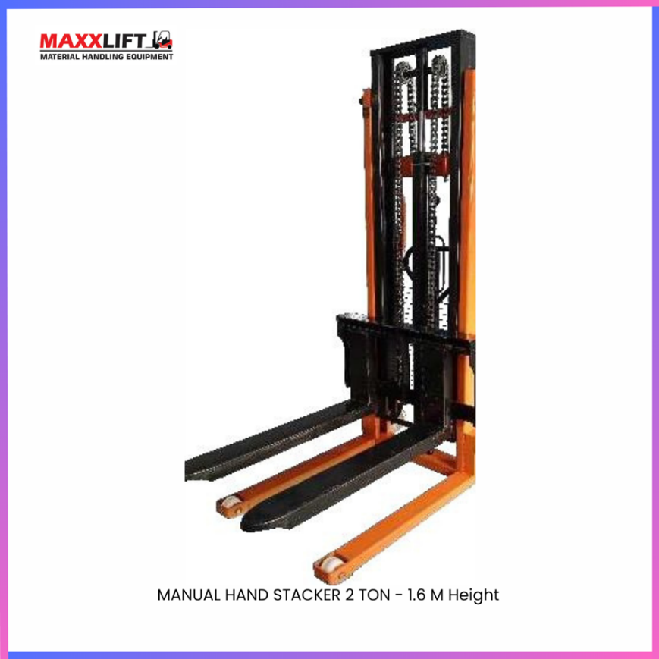
PRODUCT VIDEO - INSERT LINK FROM -INSTAGRAM / YOUTUBE
Technical Specifications
Parameter | Detail | Parameter | Detail
Model No. | TIL-Hand Stacker 2 Ton 1.6 Mtr. | Type | Manual Hydraulic Hand Stacker
Maximum Working Height | 1600 mm | Rated Load Capacity | 2000 kg
Load Center Distance | 550 mm | Lifting Height | 1500 mm
Minimum Fork Height | 90 mm | Fork Length | 860 mm
Single Fork Width | 160 mm | Adjustable Fork Width | 540 mm
Minimum Turning Radius | 1450 mm | Vehicle Width | 900 mm
Wheel Type | Nylon | Wheel Size | Ø 78 × 80 mm
Dimension (L × W × H) | 1350 × 680 × 2000 mm | Net Weight | 230 kg
Paint Finish | Orange and Black Powder Coating | Operation | Manual Hydraulic Pump

Key Features
- Manual hydraulic lifting system with sealed oil pump
- Chrome-plated large and small piston rods for durability
- Smooth lifting and controllable descent speed
- Adjustable fork width to handle multiple pallet sizes
- Compact structure with strong steel frame
- Easy to operate and maintain
- Ideal for loading, stacking, and transporting goods manually

Applications
- Factories and manufacturing units
- Warehouses and godowns
- Packaging and distribution centres
- Assembly workshops and small industries
- Loading and unloading area

Services and Support
MAXXLIFT offers complete installation, operator training, and after-sales support.
Spare parts and maintenance service are available through Sonipat, Gurugram, Kundli, and Bhiwadi branches.
On-site assistance available within 24–48 hours.

Warranty
Standard warranty 12 months from date of delivery covering hydraulic and structural components.
Extended warranty and AMC available on request.

Delivery
Normal delivery within 2–3 weeks after order confirmation and advance payment.
Immediate dispatch available for ready stock units.

Delivery Locations
PAN India supply including Delhi NCR, Haryana, Punjab, Rajasthan, Uttar Pradesh, Gujarat, and Maharashtra.

Why Choose MAXXLIFT
- High-quality Indian manufacturing
- Leak-proof hydraulic system with precision control
- Heavy-duty steel design for durability
- Smooth operation and minimal maintenance
- Trusted after-sales service and nationwide support

Contact Details
MAXXLIFT MOTORS PRIVATE LIMITED
Main Highway NH-44 GT Karnal Road Kundli Sonipat Opposite KFC Restaurant Haryana
Mobile 9811679096 7678272743 9950921878 9218058170
Website www.maxxlift.in

Manual Hand Stacker – 2 Ton Model No. Maxx-Hand Stacker 2T 2.6M
Overview
The MAXXLIFT Manual Hand Stacker is a reliable manual hydraulic lifting and transport vehicle designed for effortless material handling in warehouses and factories.
It is power-free and pollution-free, requiring no electricity or fuel.
The stacker is compact, durable, and easy to operate — ideal for manual loading, unloading, and pallet movement where electric stackers are not required.

Description
This manual stacker is equipped with a strong hydraulic pump, steel frame construction, and adjustable forks for various pallet sizes.
It ensures flexible operation, easy maintenance, and safe lifting performance.
The unit provides smooth and stable manual lifting up to 2.6 meters and supports a load capacity of up to 2 tons.
Suitable for short-distance transport and material storage in workshops, warehouses, and small industrial setups.
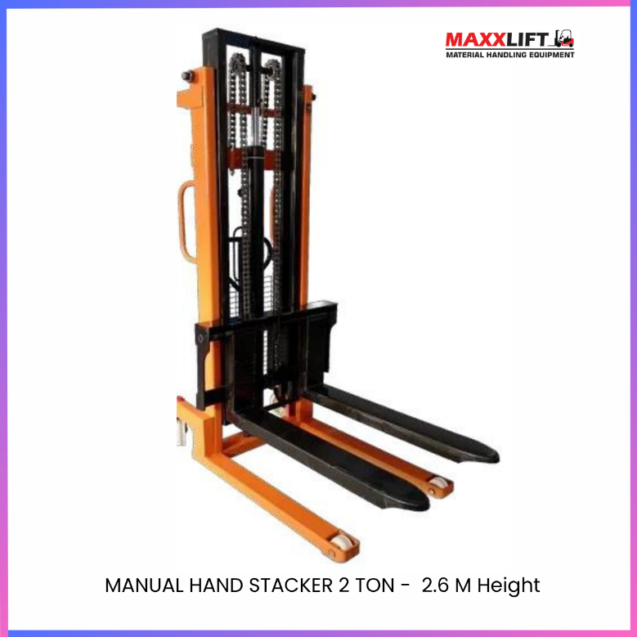
PRODUCT VIDEO - INSERT LINK FROM -INSTAGRAM / YOUTUBE

Technical Specifications
Parameter | Detail | Parameter | Detail
Model No. | Maxx-Hand Stacker 2 Ton 2.6M | Type | Manual Hydraulic Hand Stacker
Maximum Working Height | 2500 mm | Rated Load Capacity | 2000 kg
Load Center Distance | 1500 mm | Goods Fork Length | 900 mm
Pallet Fork Width Adjustment | 350 – 850 mm | Pallet Fork Minimum Height | 105 mm
Minimum Turning Radius | 1450 mm | Vehicle Length | 1500 mm
Vehicle Width | 900 mm | Vehicle Height | 2002 mm
Wheel Type | Nylon | Wheel Dimension | 50 × 90 mm
Net Weight | 300 kg | Paint Finish | Orange and Black Powder Coating

Key Features
- Manual hydraulic system with smooth lifting action
- Power-free and pollution-free operation
- Compact design and easy to manoeuvre
- Adjustable fork width for multiple pallet sizes
- Heavy-duty steel frame for long life
- Low maintenance and easy to operate
- Safe, stable, and efficient for manual loading and unloading

Applications
- Small warehouses and shops
- Factories and workshops
- Goods loading and unloading areas
- Assembly lines and packaging units
- Material stacking and pallet movement

Services and Support
MAXXLIFT provides full product demonstration, operator training, and spare parts support.
Maintenance and repair services are available through our Sonipat, Gurugram, Kundli, and Bhiwadi branches.

Warranty
Standard warranty 12 months from the date of delivery covering hydraulic and mechanical components.
Extended service plans available upon request.

Delivery
Standard delivery within 2–3 weeks after order confirmation and advance payment.
Immediate dispatch available for ready stock models.

Delivery Locations
PAN India supply including Delhi NCR, Haryana, Punjab, Rajasthan, Uttar Pradesh, Gujarat, and Maharashtra.

Why Choose MAXXLIFT
- Proven Indian manufacturing quality
- Rugged and dependable design
- Easy operation and maintenance
- Compact and economical manual solution
- Reliable after-sales service and nationwide network

Contact Details
MAXXLIFT MOTORS PRIVATE LIMITED
Main Highway NH 44 GT Karnal Road Kundli Sonipat Opposite KFC Restaurant Haryana
Mobile 9811679096 7678272743 9950921878 9218058170
Website www.maxxlift.in

Manual Hand Stacker – 1 Ton / 1.6M
Model Maxx-Hand Stacker 1 Ton

Overview
The MAXXLIFT Manual Hand Stacker 1 Ton is a simple, durable, and easy-to-operate hydraulic lifting equipment designed for small warehouses, shops, and factories.
It is power-free, pollution-free, and ideal for lifting, stacking, and transporting light to medium-weight pallets or goods.
Built with a high-strength steel frame and precision hydraulic system, it delivers reliable manual performance with minimal maintenance.

Description
This manual stacker features a sealed integral oil pump with large and small chromium-plated piston rods ensuring strength and durability.
Its compact design and adjustable forks make it suitable for various pallet sizes and tight working areas.
Easy maintenance, smooth operation, and stable lifting performance make it a perfect choice for short-distance goods movement in manufacturing and storage units.
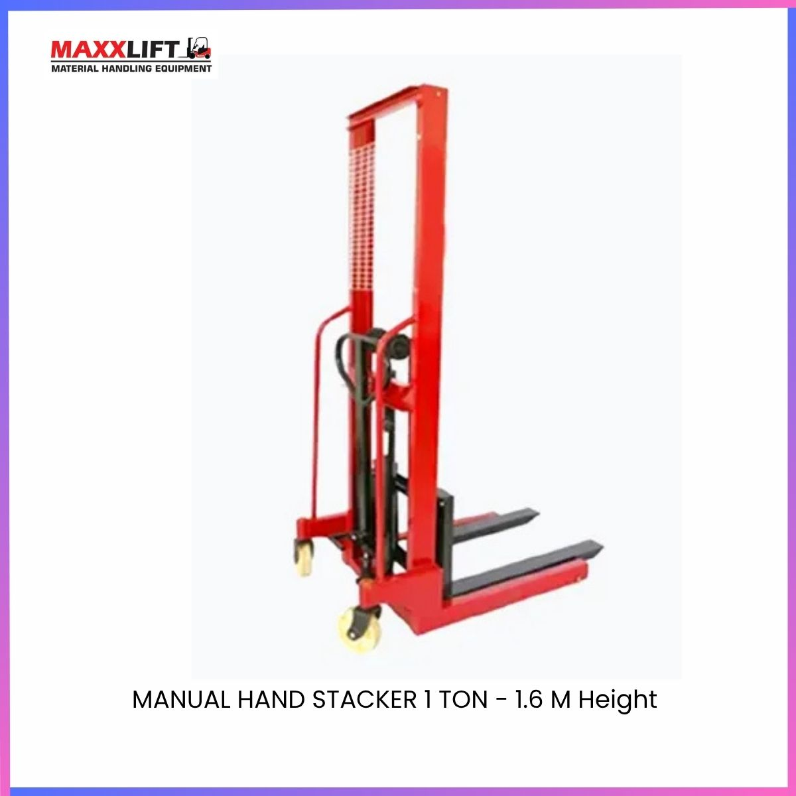
PRODUCT VIDEO - INSERT LINK FROM -INSTAGRAM / YOUTUBE

Technical Specifications
Parameter | Detail | Parameter | Detail
Model No. | Maxx-Hand Stacker 1 Ton 1.6 m | Type | Manual Hydraulic Hand Stacker
Maximum Working Height | 1600 mm | Rated Load Capacity | 1000 kg
Load Centre Distance | 550 mm | Fork Height (Max / Min) | 1600 mm / 90 mm
Fork Length | 900 mm | Single Fork Width | 100 mm
Fork Overall Width | 230 – 730 mm | Adjustable Fork Width | 540 mm
Vehicle Width | 900 mm | Ground Clearance | 23 mm
Minimum Turning Radius | 1375 mm | Front Wheel Size | Ø 50 × 90 mm
Rear Wheel Size | Ø 50 × 180 mm | Dimension (L × B × H) | 1600 × 700 × 1949 mm
Net Weight | 170 kg | Paint Finish | Orange and Black Powder Coating

Key Features
- Manual hydraulic system with integral sealed oil pump
- Strong and durable piston rods with chromium plating
- Compact structure for easy handling and storage
- Adjustable fork width for multiple pallet sizes
- Smooth manual operation with low maintenance
- Power-free and environment-friendly design
- Stable lifting and easy mobility
Applications
- Small warehouses and shops
- Assembly lines and workshops
- Loading and unloading of materials
- Storage and packaging areas
- Light industrial and maintenance operations
Services and Support
MAXXLIFT provides product training, operator guidance, and spare-part availability through Sonipat, Gurugram, Kundli, and Bhiwadi branches.
Quick on-site service is available within 24 to 48 hours.
Warranty
Standard warranty 12 months from the date of delivery covering hydraulic and structural parts under normal use.
Extended warranty and service contracts available on request.
Delivery
Standard delivery 2 to 3 weeks after order confirmation and advance payment.
Immediate delivery available for ready-stock units.
Delivery Locations
PAN India – Delhi NCR Haryana Punjab Rajasthan Uttar Pradesh Gujarat Maharashtra and other industrial regions.
Why Choose MAXXLIFT
- Proven Indian manufacturing and engineering quality
- Sturdy and long-lasting design
- Economical and power-free lifting solution
- Reliable after-sales and service network
- Consistent MAXXLIFT branding and build excellence
Contact Details
MAXXLIFT MOTORS PRIVATE LIMITED
Main Highway NH-44 GT Karnal Road Kundli Sonipat Opposite KFC Restaurant Haryana
Mobile 9811679096 7678272743 9950921878 9218058170
Website www.maxxlift.in

Manual Hand Stacker Drum Lifter and Tilter
Model No. MAXX-Manual Hand Stacker Drum Lifter and Tilter

Overview
The MAXXLIFT Manual Drum Lifter and Tilter is a versatile manual hydraulic lifting and tilting device designed for handling 55-gallon drums safely and efficiently.
Built for lifting, rotating, and transporting drums in factories and warehouses, it combines strength, stability, and smooth operation.
Compact, flexible, and easy to operate by a single person, this machine ensures precise drum positioning and spill-free tilting for industrial use

Description
The column of the body is made of high-strength C-shaped steel for durability and rigidity.
The hydraulic cylinder is equipped with a 30 mm hard chrome-plated solid piston rod and premium oil seals that eliminate oil leakage and ensure long service life.
A pulley transmission system between the masts prevents swing and maintains smooth vertical movement.
This design offers stable walking, controllable lifting speed, and smooth operation even in confined spaces.
It is ideal for drum loading, unloading, lifting, and tilting operations in chemical, food, and logistics industries.
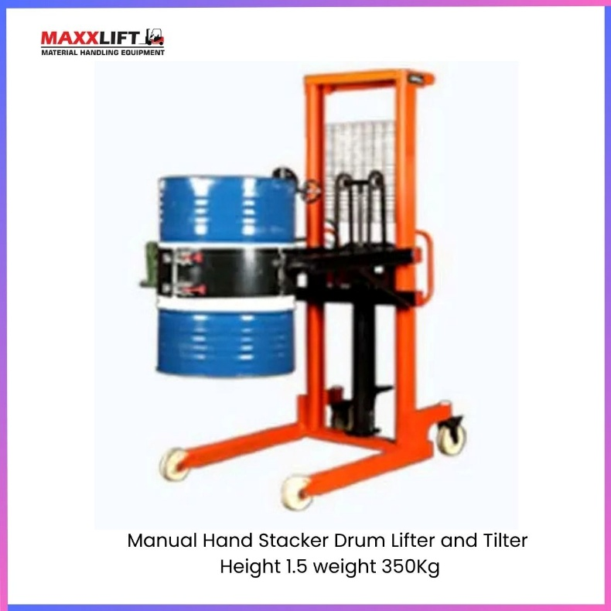
PRODUCT VIDEO - INSERT LINK FROM -INSTAGRAM / YOUTUBE

Technical Specifications
Parameter | Detail | Parameter | Detail
Model No. | MAXX-Manual Hand Stacker Drum Lifter and Tilter | Type | Manual Hydraulic Drum Handling Equipment
Rated Load | 350 kg | Suitable Drum Size | 55 Gallon Standard
Maximum Lift Height | 1350 mm | Operation Type | Manual Pump Lift and Tilt
Structure Material | C-Shaped Heavy Steel Column | Piston Rod | 30 mm Hard Chrome-Plated Solid Rod
Oil Seal | Premium Leak-Proof Seal | Transmission | Pulley Drive Between Masts
Movement | Manual Push with Nylon Wheels | Operator Requirement | Single Person
Net Weight | 190 kg | Paint Finish | Orange and Black Powder Coating

Key Features
- Hydraulic drum lifter and tiller for 55-gallon drums
- Smooth and controllable lifting and tilting motion
- Compact and lightweight for one-person operation
- Chrome-plated solid piston rod for long service life
- Pulley-based mast system eliminates swing during lift
- High-quality oil seals prevent hydraulic leakage
- Stable structure with flexible handling and fast response

Applications
- Drum loading and unloading in warehouses
- Chemical and paint industries
- Food and beverage processing plants
- Oil and lubricant storage facilities
- Factory material handling and transport

Services and Support
MAXXLIFT provides product demonstration, operator training, and maintenance services.
Spare parts and repair support are available at Sonipat, Gurugram, Kundli, and Bhiwadi branches.
On-site service within 24 – 48 hours ensures uninterrupted operations.

Warranty
Standard warranty 12 months from date of delivery covering hydraulic and structural components.
Extended warranty and annual maintenance contract available on request.

Delivery
Standard delivery within 2 – 3 weeks after order confirmation and advance payment.
Immediate dispatch available for ready-stock models.

Delivery Locations
Available PAN India including Delhi NCR, Haryana, Punjab, Rajasthan, Uttar Pradesh, Gujarat, and Maharashtra.

Why Choose MAXXLIFT
- Reliable Indian engineering and construction
- Smooth drum rotation and secure tilting
- Strong C-section steel mast design
- Leak-proof hydraulic system for long life
- Easy operation with single-person handling
- Excellent after-sales and service network

Contact Details
MAXXLIFT MOTORS PRIVATE LIMITED
Main Highway NH-44 GT Karnal Road Kundli Sonipat Opposite KFC Restaurant Haryana
Mobile 9811679096 7678272743 9950921878 9218058170
Website www.maxxlift.in

Fully Electric Counter Balance Stacker
Model - MAXX-Counter Meter Stacker 2T – 3/4.5/6 M

Overview
The MAXXLIFT Fully Electric Counter Balance Stacker is a high-capacity lifting solution built for handling heavy pallets and industrial loads up to 2 tons.
Its counterweight design eliminates the need for support legs, allowing direct loading and unloading from pallets, trucks, and racks.
Available in 3 m, 4.5 m, and 6 m lift heights, it offers smooth, quiet, and energy-efficient operation with superior stability.
Machine Description
This electric stacker features a powerful AC drive system, ergonomic control handle, and advanced MOS speed control technology for precision movement.
The reinforced steel mast ensures stable lifting at high elevations, while the built-in counterweight provides perfect balance.
Equipped with a high-capacity assembled battery, it supports long working hours and high-duty applications in warehouses, logistics hubs, and factories.
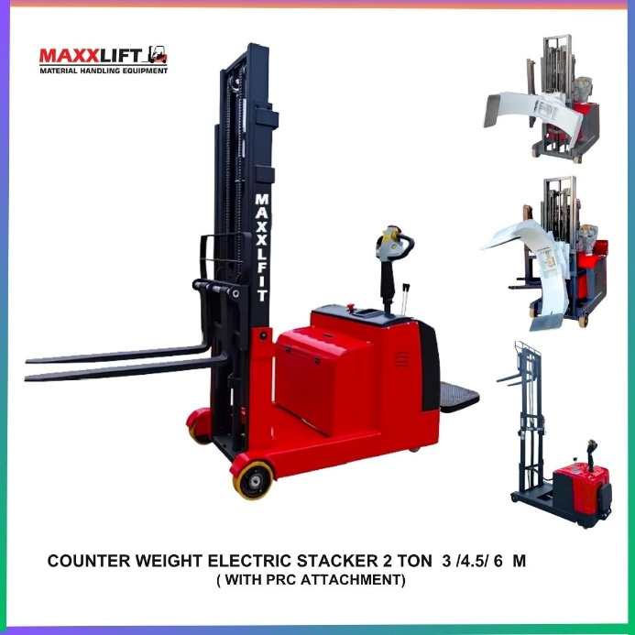

Technical Specifications
Parameter | Detail | Parameter | Detail
Model No. | MAXX-Counter Meter Stacker 2T | Power Unit | Assembled Battery
Drive Type | Stationary Electric | Rated Load | 1500 – 2000 kg
Load Centre Distance | 500 mm | Mast Type | Duplex / Triplex
Lift Height Options | 3000 mm / 4500 mm / 6000 mm | Lowered Mast Height | 2100 mm – 2600 mm
Fork Length | 1070 mm | Fork Width | 680 mm (Adjustable)
Fork Type | Forged Heavy Steel | Tilt Function | Forward & Backward
Turning Radius | 1700 mm | Wheelbase | 1350 mm
Drive Motor Power | 2.2 kW AC | Lift Motor Power | 3.0 kW AC
Battery Voltage | 24 V | Battery Capacity | 280 – 320 Ah
Controller | MOS Stepless Speed Control | Brake System | Electromagnetic
Travel Speed (Full / Empty Load) | 4.0 / 6.0 km per hour | Max Gradeability | 8% (Full) / 12% (Empty)
Tyre Type | PU / Solid Rubber | Wheel Size (Front / Rear) | Ø 230 × 80 / Ø 80 × 70 mm
Overall Length | 2200 mm | Overall Width | 1100 mm
Overall, Height (Mast Lowered) | 2100 – 2600 mm | Machine Weight | 1500 – 1800 kg
Paint Finish | Red and Black | Operation Mode | Walk-Behind or Ride-On (Optional)

Key Features
- Counterweight design for direct pallet access
- High lift range up to 6 meters
- Fully electric operation with smooth hydraulic control
- Powerful AC drive and lift motors for high performance
- MOS stepless speed control for precision handling
- Electromagnetic braking and safety interlock system
- Compact body with stable mast and counterweight balance
- Long battery backup with assembled maintenance-free unit
Applications
- Heavy pallet stacking and retrieval
- Industrial production and assembly lines
- Loading and unloading of pallets and crates
- Warehousing and high-rack storage systems
- Automotive, logistics, and manufacturing sectors
Services and Support
MAXXLIFT provides installation, operator training, and preventive maintenance.
Spare parts and technical assistance available through Sonipat, Gurugram, Kundli, and Bhiwadi branches.
On-site support within 24–48 hours ensure quick resolution.
Warranty
Standard 12-month warranty covering electrical and mechanical components.
Extended warranty and AMC available on request.
Delivery
Delivery period 2–3 weeks after order confirmation and advance payment.
Ready-stock models available for faster dispatch.
Delivery Locations
MAXXLIFT delivers PAN India — Delhi NCR, Haryana, Punjab, Rajasthan, Uttar Pradesh, Gujarat, Maharashtra, and other industrial regions.
Why Choose MAXXLIFT
- Proven performance in Indian industrial conditions
- High-stability counterweight design
- Smooth, quiet, and maintenance-free operation
- Long working hours with heavy-duty battery
- Nationwide service network and spare part support
Contact Details
MAXXLIFT MOTORS PRIVATE LIMITED
Main Highway NH-44 GT Karnal Road Kundli Sonipat Opposite KFC Restaurant Haryana
Mobile 9811679096 7678272743 9950921878 9218058170
Website www.maxxlift.in

Towable Hydraulic Scissor Lift
Model No. MAXX--Towable Hydraulic Scissor Lift-6-18 M

Overview
The MAXXLIFT Towable Hydraulic Scissor Lift is a powerful and versatile lifting platform designed for working at heights ranging from 6 meters to 18 meters.
This model provides stable elevation for construction, maintenance, and installation applications across various industries.
Equipped with a durable scissor mechanism, strong hydraulic system, and towable chassis, it ensures smooth and safe lifting operations both indoors and outdoors.
Description
This hydraulic lift is designed for easy movement and stable vertical lifting.
It uses a high-quality scissor mechanism with electric-hydraulic drive powered by a 24V / 4.5 kW motor.
The platform offers wide working space and excellent load stability, making it ideal for installation, painting, cleaning, and electrical work at heights.
Its towable design allows the lift to be easily transported to different locations, ensuring flexibility and efficiency at any job site.
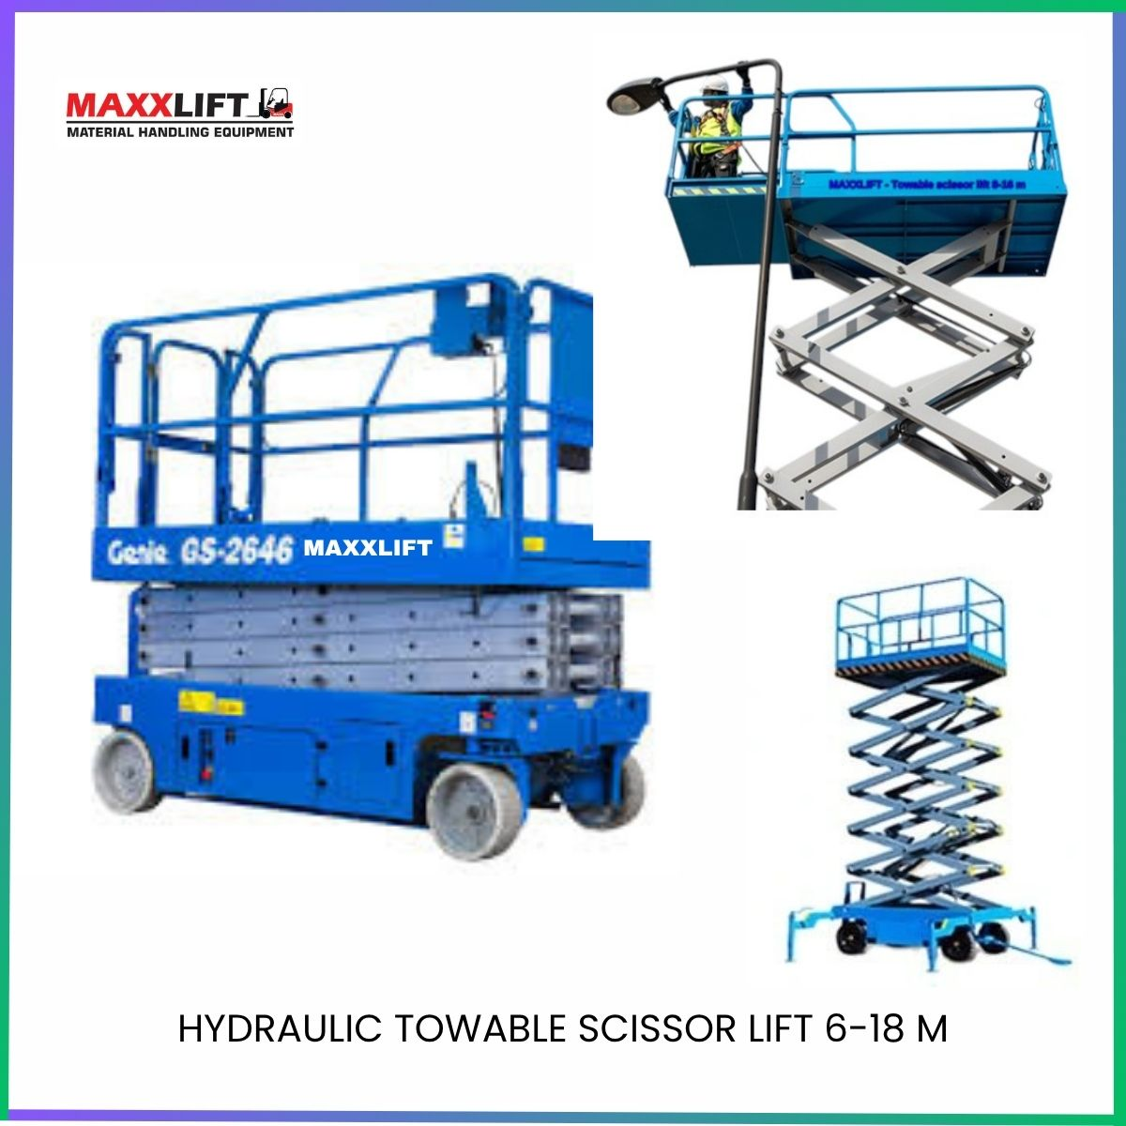
PRODUCT VIDEO- INSERT LINK from Instagram /youtube

Technical Specifications
Parameter | Detail | Parameter | Detail
Model No. | Maxx-Towable Hydraulic Scissor Lift | Type | Electric Hydraulic Scissor Lift
Table Size | 2100 × 930 mm | Load Capacity | 300 kg
Lifting Height Range | 6 – 18 meters | Minimum Lifting Height | 4 meters
Overall Dimensions | 2250 × 1060 × 1300 mm | Machine Weight | 300 kg
Power Source | 24 V / 4.5 kW | Drive Type | Electric Motor
Core Components | Hydraulic Pump Pressure Vessel Motor | Lift Mechanism | Hydraulic Scissor Arm
Lifting System | Electric Hydraulic | Power Type | AC Electric
Control Mode | Wired Remote or Manual Button | Safety System | Hydraulic Check Valve and Emergency Stop
Structure Material | High Strength Steel Frame | Paint Finish | Blue Powder Coating

Key Features
- Wide lifting ranges from 4 to 18 meters
- Stable hydraulic scissor structure with safety lock valve
- Strong AC motor and high-performance hydraulic pump
- Compact towable design for easy movement between sites
- Large platform area for safe and comfortable working space
- Suitable for both indoor and outdoor maintenance and construction work
- Smooth operation with overload protection and safety rails
Applications
The Towable Hydraulic Scissor Lift is suitable for a wide range of industries and job sites including:
- Building material shops
- Machinery repair workshops
- Manufacturing plants
- Food and beverage factories
- Farms and agricultural facilities
- Construction sites and civil works
- Energy and mining projects
- Hotels and facility maintenance
Services and Support
MAXXLIFT offers installation, training, and maintenance support for all hydraulic lifting products.
Spare parts and technical service are available through Sonipat, Gurugram, Kundli, and Bhiwadi branches.
On-site support within 24 to 48 hours for minimum downtime.
Warranty
Standard warranty 12 months from the date of delivery covering electrical and hydraulic components.
Extended warranty and AMC available on request.
Delivery
Delivery period 2 to 3 weeks after order confirmation and advance payment.
Immediate shipment available for ready stock models.
Delivery Locations
PAN India supply including Delhi NCR, Haryana, Punjab, Rajasthan, Uttar Pradesh, Gujarat, and Maharashtra.
Why Choose MAXXLIFT
- Trusted Indian manufacturer of industrial lifting solutions
- Wide range of heights up to 18 meters
- Robust hydraulic and structural engineering
- Safe, smooth, and reliable performance
- Full after-sales and technical support network
Contact Details
MAXXLIFT MOTORS PRIVATE LIMITED
Main Highway NH-44 GT Karnal Road Kundli Sonipat Opposite KFC Restaurant Haryana
Sector 35 Narsinghpur Gurugram Haryana
Mobile 9811679096 7678272743 9950921878 9218058170
Website www.maxxlift.in

550 Kg Movable Hydraulic Scissor Lift
Model No. MAXX -550 Kg Movable Hydraulic Scissor Lift

Overview
The MAXXLIFT 550 Kg Movable Hydraulic Scissor Lift is a heavy-duty self-propelled aerial platform designed for safe, stable, and efficient high-altitude operations.
Built with a powerful electric hydraulic system, it provides vertical elevation up to 7.8 meters while carrying two operators and tools safely.
Its movable design and extension platform make it ideal for indoor and outdoor industrial maintenance, construction, and installation work.
Applications
This model is suitable for multiple industries and commercial operations including:
- Building material shops
- Machinery repair workshops
- Manufacturing plants
- Food and beverage factories
- Farms and agricultural facilities
- Construction works
- Energy and mining industries
- Hotels and facility maintenance
Description
The movable scissor lift offers a wide platform with a 900 mm extension for increased working space and reach.
Its strong steel chassis and advanced hydraulic cylinders ensure stability at maximum height.
Equipped with a 24V / 4.5 kW power system and 200Ah battery pack, it delivers long operational hours with smooth movement and precise control.
Automatic safety systems and proportional lift controls provide secure, comfortable, and efficient performance for aerial maintenance and assembly work.
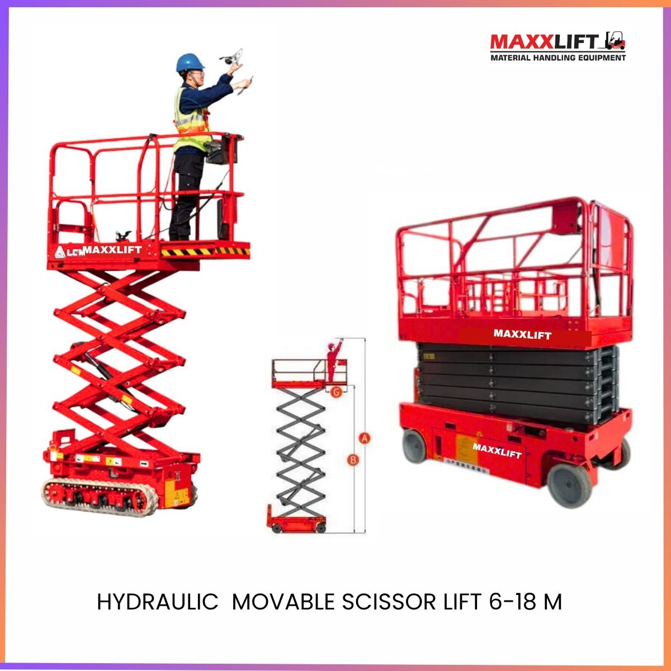
Technical Specifications
Parameter | Detail | Parameter | Detail
Model No. | Maxx-550 Kg Movable Hydraulic Scissor Lift | Working Load | 550 kg
Extension Platform Load | 113 kg | Maximum Number of Workers | 2
Maximum Working Height (A) | 6-18 Meters | Maximum Platform Height (B) | 5.8 m
Complete Machine Length (C) | 2480 mm | Overall Width (D) | 1190 mm
Overall, Height | 2190 mm | Overall, Height (Guardrail Folded) (E) | 1680 mm
Work Platform Size (F) | 2290 × 1150 mm | Platform Extension (G) | 900 mm
Minimum Ground Clearance (Closed) | 100 mm | Ground Clearance (Lifted) | 200 mm
Wheel Base | 1890 mm | Turning Radius (Inner / Outer) | 0 m / 2.2 m
Lift Motor | 24 V / 3.3 kW | Power Type | Electric
Machine Speed (Closed / Lifted) | 3.5 km/h / 0.8 km/h | Rise / Fall Time | 28 s / 38 s
Battery | 4 × 6 V / 200 Ah | Charger | 24 V / 30 A
Power System | 24 V / 4.5 kW | Climbing Capacity | 25%
Max Allowable Work Angle | 1.5° Front-Back / 3° Side-Side | Tyre Size | Ø 381 × 127 mm
Drive Type | Electric Hydraulic | Lift Mechanism | Scissor Lift
Total Machine Weight | 2150 kg | Paint Finish | Orange Powder Coating

Key Features
- Heavy-duty self-propelled scissor lift with 550 kg load capacity
- 7.8 m working height with 2-person platform capacity
- Extendable platform (900 mm) for extra working reach
- Smooth electric drive and hydraulic lift system
- Wide base and strong scissor arms ensure superior stability
- Emergency descent and overload protection system
- Compact design with zero inner turning radius for easy mobility
- Long battery backup and energy-efficient power system
Applications of Use
- Maintenance of lights, ceilings, and HVAC systems
- Painting, wiring, and installation work at height
- Construction site finishing and facade maintenance
- Warehouse inventory and repair operations
- Facility management in hotels, malls, and factories
Services and Support

MAXXLIFT provides complete installation, operator training, and maintenance service for all aerial platforms.
Spare parts and service support are available at Sonipat, Gurugram, Kundli, and Bhiwadi branches.
On-site service within 24–48 hours ensure quick assistance and minimal downtime.
Warranty
12-month standard warranty from delivery date covering electrical and hydraulic components.
Extended warranty and AMC available on request.
Delivery
Delivery time 2–3 weeks after order confirmation and advance payment.
Immediate dispatch available for ready stock models.
Delivery Locations
Available PAN India including Delhi NCR, Haryana, Punjab, Rajasthan, Uttar Pradesh, Gujarat, Maharashtra, and other industrial hubs.
Why Choose MAXXLIFT
- Proven safety and reliability in aerial operations
- Strong and durable scissor mechanism
- Easy operation and low maintenance cost
- Smooth electric-hydraulic lift performance
- Trusted after-sales service and nationwide coverage

Contact Details
MAXXLIFT MOTORS PRIVATE LIMITED
Main Highway NH-44 GT Karnal Road Kundli Sonipat Opposite KFC Restaurant Haryana
Mobile 9811679096 7678272743 9950921878 9218058170
Website www.maxxlift.in

Single Mast Aerial Platform
Model No. MAXXLIFT-Single Mast Aerial Platform- 4-14 M

Overview
The MAXXLIFT Single Mast Aerial Platform is a compact and lightweight vertical lifting solution ideal for single-person operations at height.
Manufactured with high-strength aluminium alloy, it ensures excellent balance, stability, and manoeuvrability.
This lift is suitable for maintenance, installation, and inspection work at warehouses, workshops, and construction sites.
Its portable design, easy movement, and safety features make it the perfect choice for height access in narrow spaces.
Applications
- Warehouses and godowns
- Construction and building maintenance
- Roadside electrical work
- Workshops and factories
- Showrooms and commercial facilities

Description
This single mast aerial platform uses advanced aluminium alloy for strength and lightweight performance.
It is designed with a stable base, remote control operation, and reliable safety systems for operator security.
Equipped with polyurethane wheels for silent and smooth movement, the lift can easily pass through standard doors and corridors.
Available in multiple height variants up to 12 meters, this model combines flexibility, portability, and performance for a wide range of indoor and outdoor applications.
Key Features
- High-quality aluminium alloy structure with attractive design
- Compact size and lightweight body for easy mobility
- Safety rope and protection device for operator security
- Remote control box for convenient operation
- Polyurethane tyres for quiet and non-marking movement
- Multiple height configurations available
- Strong mast structure for stable and balanced lifting
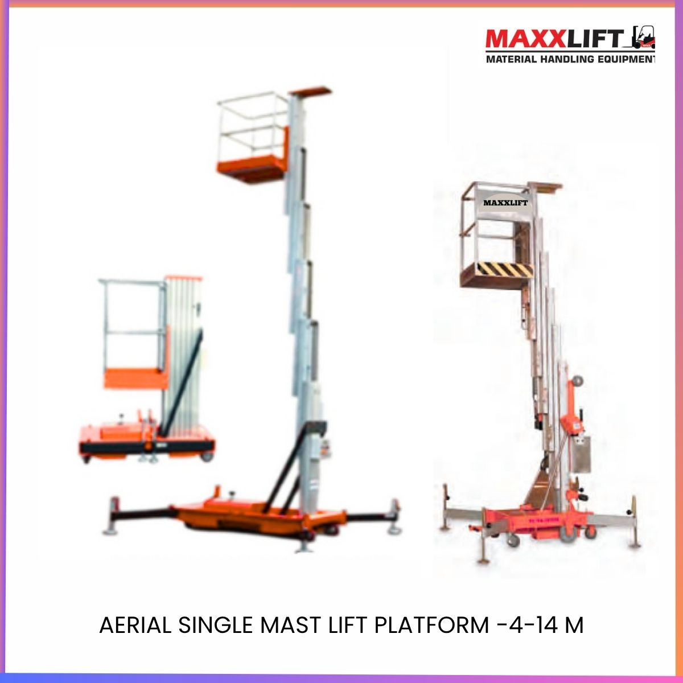

PRODUCT VIDEO – INSERT LINK FROM TOU TUBE / INSTA

Technical Specifications
Parameter | Detail | Parameter | Detail
Model No. | MAXX-Single Mast Aerial Platform | Structure Type | Single Mast Aluminium Alloy
Lifting Height Options | 4 m / 6 m / 8 m / 10 m / 12 m/14 | Load Capacity | 100 kg / 130 kg / 150 kg
Power | 1.1 kW | Power Type | AC Electric
Control System | Remote and Manual | Tyre Type | Polyurethane non-marking
Application | Warehouse / Workshop / Construction Site | Drive Type | Manual Push with Electric Lift
Machine Dimension | 1300 × 800 × 1980 mm | Machine Weight | 280 kg
Safety Features | Safety Rope and Protection Device | Paint Finish | Orange Powder Coating

Advantages
- Excellent balance and stability during operation
- Small turning radius and easy manual movement
- Safe and reliable for single-person aerial work
- Low maintenance and energy-efficient design
- Lightweight structure for easy transport between job sites
Services and Support
MAXXLIFT provides full installation, training, and service support for aerial platforms.
Spare parts and technical assistance are available through Sonipat, Gurugram, Kundli, and Bhiwadi branches.
On-site service is provided within 24–48 hours.
Warranty
Standard warranty 12 months from delivery covering electrical and mechanical components under normal working conditions.
Extended warranty and AMC available on request.
Delivery
Delivery period 2–3 weeks after order confirmation and advance payment.
Immediate dispatch available for ready stock models.
Delivery Locations
PAN India coverage including Delhi NCR, Haryana, Punjab, Rajasthan, Uttar Pradesh, Gujarat, Maharashtra, and other industrial regions.
Why Choose MAXXLIFT
- Compact and versatile aluminium mast design
- Easy to operate and transport
- Excellent safety and balance performance
- Reliable and low-maintenance engineering
- Nationwide service and support network
Contact Details
MAXXLIFT MOTORS PRIVATE LIMITED
Main Highway NH-44 GT Karnal Road Kundli Sonipat Opposite KFC Restaurant Haryana
Mobile 9811679096 7678272743 9950921878 9218058170
Website www.maxxlift.in

Dual Mast Aerial Platform
Model No.: -MAXX-Dual Mast Aerial Platform
Applications
- Warehouses and storage units
- Construction and maintenance sites
- Roadside electrical installation works
- Industrial workshops and fabrication areas
Description
The MAXXLIFT Dual Mast Aerial Platform is designed for safe, stable, and high-altitude operations such as maintenance, cleaning, and installation work.
Constructed using high-strength aluminium alloy, this lift provides an excellent balance between lightweight mobility and robust lifting performance.
The dual mast design enhances platform stability, making it ideal for working heights up to 16 meters. The equipment features quiet polyurethane wheels, remote-control operation, and safety ropes, ensuring maximum reliability and operator comfort.
This lift can be easily moved by one person, making it the most convenient choice for compact workplaces and multi-location maintenance tasks.
Key Features
- Dual Mast Design – Superior stability during lifting and operation.
- Aluminium Alloy Structure – Lightweight, corrosion-resistant, and durable.
- Remote Control Operation – Up-down control for easy handling.
- Safety Protection System – Safety rope and emergency lowering valve.
- Low Noise & Non-Marking PU Wheels – Smooth and floor-friendly movement.
- Compact & Portable – Easily towable by one person.
- Multi-Mast Options Available – Single, double, triple, and quad mast configurations.

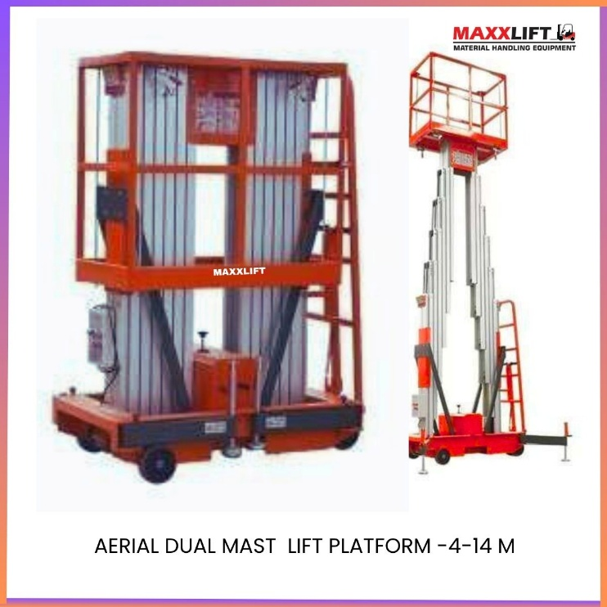

Technical Specifications
Parameter | Specification | Parameter | Specification
Model No. | MAXX-Dual Mast Aerial Platform | Product Type | Electric Aluminium Lift
Lifting Height | 6m / 8m / 10m / 12m / 14m | Working Height | 8m / 10m / 12m / 14m / 16m
Power | 1.1 kW | Power Supply | AC 220V / 50Hz
Load Capacity | 150–200 Kg | Platform Material | High-Strength Aluminium Alloy
Control Method | Remote Control Box | Wheel Type | Polyurethane (PU) Tyres
Safety Features | Safety Rope & Emergency Valve | Outriggers | Heavy-Duty Stabilizing Legs
Dimension (L×W×H) | 2655 × 1350 × 2000 mm | Net Weight | 275 Kg
Operation Type | Electric Lift / Manual Push | Noise Level | Low (<60 dB)

Ideal For
- Electrical maintenance & wiring
- Ceiling repair, cleaning & painting
- Installation of lighting or signage
- Warehousing and factory servicing
Maintenance & Service
- Inspect hydraulic system and safety locks monthly.
- Lubricate guide rails every 3 months.
- Check the battery or power line regularly for wear.
- MAXXLIFT service available across Sonipat, Gurugram, Kundli, and Bhiwadi.
Warranty
- 1 Year Warranty on electrical and hydraulic components.
- Lifetime service support and spare part availability from MAXXLIFT Motors Pvt. Ltd.

Fully Electric Single Arm Crane – Mobile Crane
Model No. MAXXLIFT – Fully Electric Single Arm Crane

Overview
The MAXXLIFT Fully Electric Single Arm Crane is a compact, high-performance mobile crane designed to replace traditional electric forklifts in confined spaces.
With a telescopic adjustable boom and powerful electric drive system, it enables precise lifting, positioning, and transportation of heavy loads safely and efficiently.
Ideal for workshops, factories, and service areas, this model offers full electric operation, foldable legs, and simple controls — making it one of the most versatile lifting solutions for industrial environments.
Applications
- Warehouses and manufacturing plants
- Machine maintenance and assembly areas
- Construction and building interiors
- Industrial workshops and logistics hubs
- Narrow or restricted workspaces where forklifts cannot enter
Features
- Fully electric operation for lifting and movement
- Adjustable telescopic boom with wide lifting angles
- Foldable outriggers for compact storage and easy transport
- Ideal replacement for forklifts in tight areas
- Smooth, precise lifting and easy manoeuvrability
- Long boom reach for extended working range
- Low maintenance with energy-efficient electric system
Description
The MAXXLIFT Fully Electric Single Arm Crane combines mobility, power, and precision.
Its strong single-arm telescopic boom offers multiple reach and angle options, enabling lifting of loads up to 1000 kg.
The crane operates fully on electric power — no manual pumping required — offering smooth hydraulic lifting and controlled movement.
Foldable support legs reduce storage space, while heavy-duty wheels ensure stable movement on any floor type.
Built with a robust steel frame and premium electrical components, it’s the perfect solution for safe and efficient lifting in industrial environments.
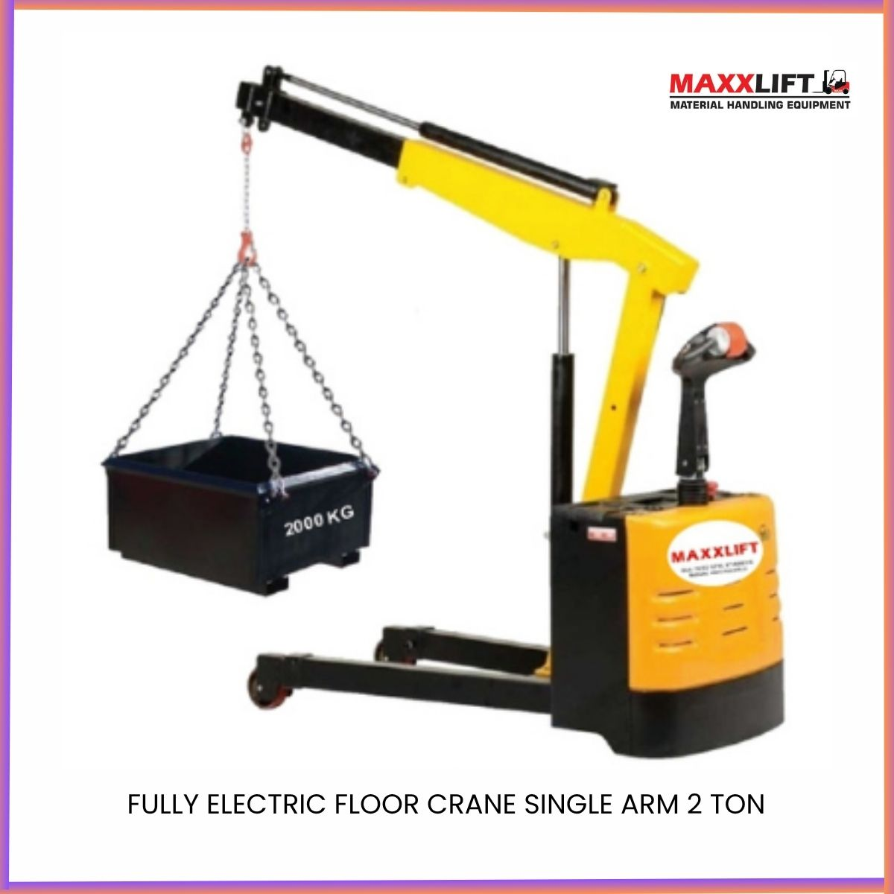

Technical Specifications
Parameter | Detail | Parameter | Detail
Model No. | MAXXLIFT – Fully Electric Single Arm Crane | Operation Type | Fully Electric
Power Source | Electric Motor | Structure | Single Arm Telescopic Boom
Maximum Rated Load | 1000 kg | Net Weight | 466 kg
Outrigger Inner Width | 985 mm | Outrigger Outer Width | 1170 mm
Front Wheel Size | Ø 150 × 50 mm | Training Wheel Size | Ø 75 × 30 mm
Boom Type | Adjustable Telescopic | Lifting Control | Electric Hydraulic

Load Capacity Table by Boom Angle
Boom Angle | Boom Length (mm) | Rated Load (kg)
0° | 440 / 2300 / 2500 / 2700 / 2900 / 3100 | 1000 / 342 / 290 / 250 / 220 / 200
40° | 985 / 1610 / 1756 / 1900 / 2045 / 2090 | 1000 / 565 / 430 / 345 / 290 / 250

Key Advantages
- 100% electric lifting and travel control
- Compact design ideal for limited workspaces
- Wide range of lifting angles and telescopic boom
- Strong structural stability with safe hydraulic performance
- Quiet, efficient, and eco-friendly electric drive system
- Foldable outriggers for quick deployment and mobility
- Long service life and low maintenance cost
Services and Support
MAXXLIFT provides installation, product training, and maintenance services.
Service and spare part support available at Sonipat, Gurugram, Kundli, and Bhiwadi branches.
On-site service within 24–48 hours for quick assistance.
Warranty
12-month standard warranty from date of delivery covering electrical and hydraulic systems.
Extended warranty and AMC available on request.
Delivery
Standard delivery within 2–3 weeks after order confirmation and advance payment.
Immediate dispatch available for ready-stock models.
Delivery Locations
PAN India supply including Delhi NCR, Haryana, Punjab, Rajasthan, Uttar Pradesh, Gujarat, Maharashtra, and major industrial zones.
Why Choose MAXXLIFT
- Precision-engineered Indian manufacturing
- Compact, safe, and energy-efficient design
- Fully electric lifting and driving system
- Durable construction with minimal maintenance
- Reliable after-sales and service support across India
Contact Details
MAXXLIFT MOTORS PRIVATE LIMITED
Main Highway NH-44 GT Karnal Road Kundli Sonipat Opposite KFC Restaurant Haryana
Mobile 9811679096 7678272743 9950921878 9218058170
Website www.maxxlift.in

Semi Electric Floor Crane – Single Arm 2 Ton
Model No.: MAXX–Semi Electric Single Arm Crane

Product Description
The MAXXLIFT Semi Electric Single Arm Floor Crane is a versatile and compact lifting solution designed for indoor and outdoor industrial use.
It replaces the need for a forklift in areas with restricted access or tight spaces, allowing operators to lift and position heavy loads easily.
With a wide range of lifting angles, an adjustable telescopic boom, and foldable legs, this machine ensures smooth operation, stable lifting, and easy transport.
Ideal for maintenance, assembly lines, machine shops, and logistics areas, this crane combines power with portability.
Key Features
- Semi-Electric Operation – Electric lift with manual movement for precise control.
- Telescopic Boom Design – Adjustable reach for flexible load handling.
- Compact & Foldable Legs – Easy storage and transport.
- Wide Lifting Range – Suitable for different material sizes and work conditions.
- Durable Hydraulic System – Reliable performance with low maintenance.
- High Stability – Equipped with extended outriggers and safety valves.
- Ideal for Indoor Operations – Smooth, quiet, and efficient lifting solution.

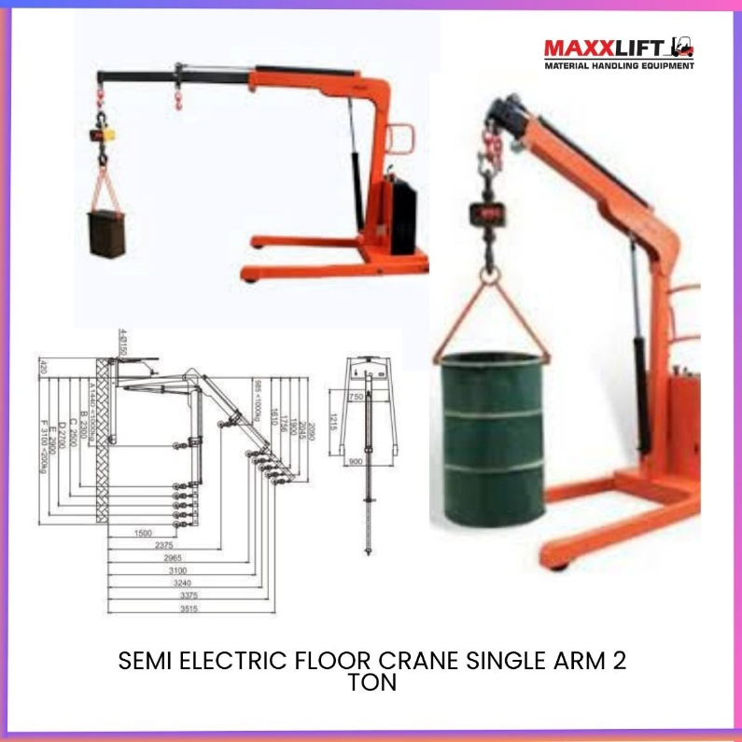
Technical Specifications
Parameter | Specification | Parameter | Specification
Model No. | MAXX–Semi Electric Single Arm Crane | Product Type | Semi Electric Floor Crane
Rated Capacity | 2000 Kg (2 Ton) | Operation Type | Electric Lift / Manual Travel
Boom Length (0°) | 440 / 2300 / 2500 / 2700 / 2900 / 3100 mm | Rated Load (0°) | 1000 / 342 / 290 / 250 / 220 / 200 Kg
Boom Length (40°) | 985 / 1610 / 1756 / 1900 / 2045 / 2090 mm | Rated Load (40°) | 1000 / 565 / 430 / 345 / 290 / 250 Kg
Outrigger Inner Width | 985 mm | Outrigger Outer Width | 1170 mm
Net Weight | 466 Kg | Wheel Type | PU-Coated Industrial Wheels
Front Wheel Size | Ø150 × 50 mm | Training Wheel Size | Ø75 × 30 mm
Lifting Power | Electric Hydraulic | Power Source | 220V AC / 24V DC
Frame Material | High-Strength Steel | Control | Push-Button Control Box
Applications
- Machine loading/unloading operations
- Workshops & maintenance areas
- Automobile & component assembly
- Small warehouses & logistics centres
- Industrial repair & lifting applications
Maintenance & Service
- Check hydraulic oil levels every 6 months.
- Grease joints and wheels periodically.
- Inspect boom pins and outriggers before use.
- MAXXLIFT service centres available in Sonipat, Gurugram, Kundli & Bhiwadi.
Warranty
- 1 Year Warranty on hydraulic, electric, and structural components.
- Lifetime service and parts support from MAXXLIFT Motors Pvt. Ltd.

Fully Automatic Electric Hand Pallet Truck – 2 Ton
Model No-MAXXLIFT – 2.0 T
Overview
The MAXXLIFT Fully Automatic Electric Hand Pallet Truck is a high-performance, battery-powered pallet mover built for effortless material handling.
It combines compact design, high efficiency, and smooth control for transporting heavy pallets with minimal effort.
Ideal for warehouses, production floors, and logistics operations, this model ensures maximum productivity with zero manual lifting.
Highlight Features
- Fully Electric Operation – powered by a 48 V / 140 Ah maintenance-free battery
- High Efficiency & Performance – travel speed up to 5.5 km / h (empty) and 3.5 km / h (loaded)
- Strong 2 Ton Load Capacity – reliable for continuous heavy-duty pallet transport
- Compact Stand-On Design – easy to operate in narrow aisles
- Smooth and Silent Operation – polyurethane wheels for low noise and floor protection
- Electromagnetic Braking System – enhanced safety and stable stopping
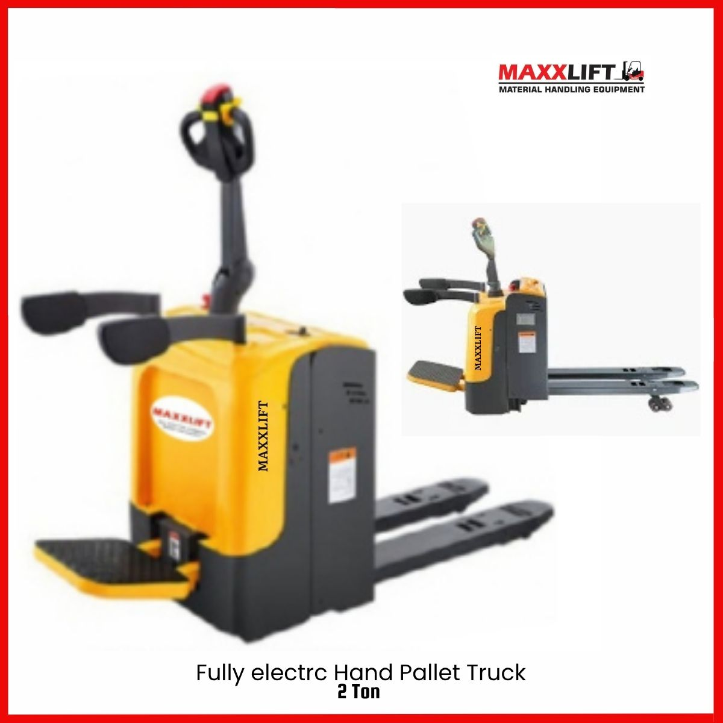

Technical specification
Parameter | Detail | Parameter | Detail
Model No. | MAXX – FEHPT-2.0T | Operation Type | Stand-On
Rated Load Capacity | 2000 Kg | Payload Centre | 475 mm
Fork Length | 1200 mm | Fork Width | 160 mm
Maximum Fork Width | 685 mm | Fork Low Height | 85 mm
Fork Highest Height | 1220 mm | Fork Height From Ground | 85 mm
Tire Type | Polyurethane (PU) | Turning Radius | 1530 mm
Driving Wheel Size | Ø160 × 55 mm | Balance Wheel Size | 115 × 55 mm
Carrying Wheel Size | Ø80 mm | Lifting Height | 200 mm
Traveling Speed (Loaded) | 3.5 km/h | Traveling Speed (Empty) | 5.5 km/h
Climbing Ability | 6% | Braking Method | Electromagnetic
Drive Motor Power | 1.2 kW | Battery Voltage / Capacity | 48 V / 140 Ah
Vehicle Length | 2500 mm | Construction | Steel Chassis with PU Wheels

Applications
Warehouses and distribution centres
Manufacturing and assembly lines
Retail storage and logistics hubs
Industrial plants and material handling units
Loading / unloading / goods-movement areas
Advantages
- Compact & manoeuvrable for tight spaces
- Energy-efficient electric drive system
- Zero manual effort – reduces operator fatigue
- Durable frame for heavy-duty industrial use
- High safety standards with auto-brake system
- Available in 2 T / 3 T / 5 T capacity options
Services and Support
MAXXLIFT provides complete installation, operator training, and after-sales service.
Service centres and spare-part support available at Sonipat, Gurugram, Kundli, and Bhiwadi.
On-site assistance within 24 – 48 hours.
Warranty
Standard 12-month warranty from date of delivery on electrical and mechanical components.
Extended warranty and annual maintenance contracts available on request.
Delivery
Delivery within 2–3 weeks after order confirmation and advance payment.
Ready-stock units available for immediate dispatch.
Delivery Locations
PAN India supply – Delhi NCR, Haryana, Punjab, Rajasthan, Uttar Pradesh, Gujarat, Maharashtra and other industrial regions.
Why Choose MAXXLIFT
- 100 % Indian manufacturing excellence
- Compact design for high manoeuvrability
- Energy-efficient and maintenance-free operation
- Durable construction for long service life
- Dedicated after-sales network across India
Contact Details
MAXXLIFT MOTORS PRIVATE LIMITED
Main Highway NH-44, GT Karnal Road, Kundli, Sonipat – Opposite KFC Restaurant, Haryana
9811679096 7678272743 9950921878 9218058170
Website – www.maxxlift.in

Electric Pallet Truck – 2 Ton (Battery Operated)
Model No.: MAXX-EHPT-2T
Description
The MAXXLIFT Electric Pallet Truck is a power-assisted material-handling solution designed to make pallet movement easy, efficient, and fatigue-free.
With an integrated lead-acid battery system (48 V / 20 AH), it provides long operating hours and quick recharging.
This compact and durable truck is ideal for warehouses, logistics hubs, and production lines, where silent operation and high efficiency are essential.
Key Features
- Fully Electric Drive & Lift System – Effortless movement with minimal manual effort.
- Lead-acid Battery (48 V / 20 AH) – Reliable, long-life, and easy to maintain.
- Compact Design – Works efficiently in narrow aisles and storage areas.
- Quiet Operation – Low-noise drive motors and smooth PU wheels.
- Sturdy Fork Construction – High-strength steel with wide fork spacing for stability.
- Safety Handle with Controls – Forward, reverse, brake, and horn integrated.
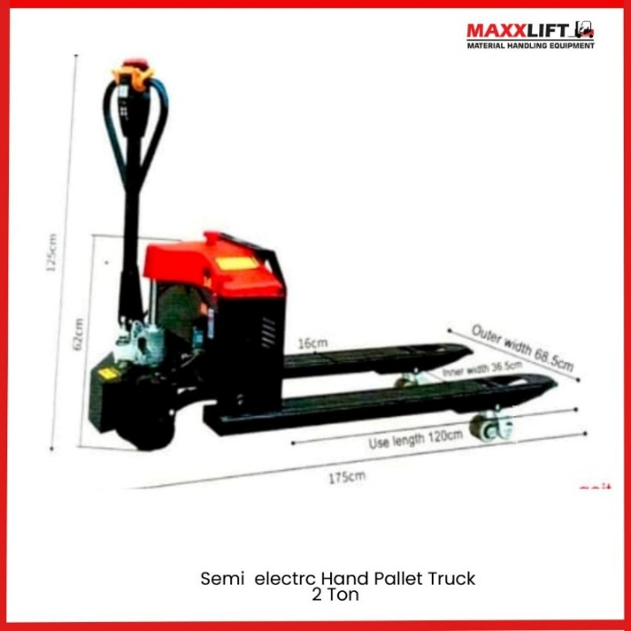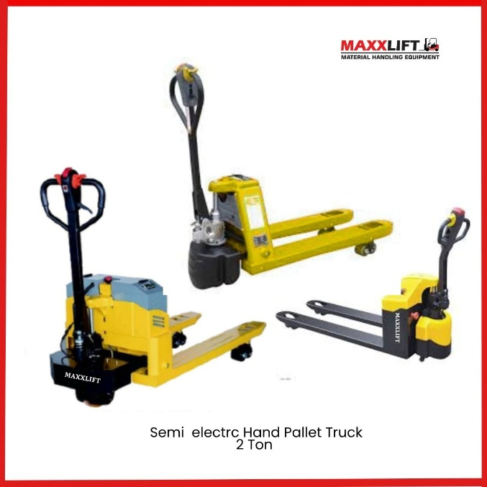

Technical Specifications
Parameter | Specification | Parameter | Specification
Model No. | MAXX-EHPT-2T | Product Type | Electric Pallet Truck
Fork Length | 1200 mm | Fork Outer Width | 550 – 685 mm
Inside Width of Cargo Fork | 230 – 365 mm | Lifting Method | Electric Lifting
Battery Type | Lead-acid Cell | Battery Capacity | 48 V / 20 AH
Formal Velocity | 5 km/h | Rated Capacity | 2000 Kg
Drive Wheel Size | Ø 160 mm × 55 mm | Front Wheel Size | Ø 80 mm × 70 mm
Construction | High-Strength Alloy Steel | Tyre Material | Polyurethane (PU)
Power Supply | 220 V AC Charging | Operation Type | Electric Drive / Manual Steer
Applications
- Warehouses & logistics centres
- Retail stockrooms
- Production & assembly lines
- Transport and loading bays
Maintenance Tips
- Charge battery after each shift for optimal life.
- Keep battery terminals clean and check electrolyte monthly.
- Grease wheel bearings and pivot points every 3 months.
- Store indoors and avoid long-term discharge.
Warranty
- 1-year warranty on electrical, hydraulic, and structural components.
- Lifetime service support and spare parts available through MAXXLIFT Motors Pvt. Ltd.

Scissor Hand Pallet Truck – 1.5 Ton Capacity
Model No. MAXX-SHPT1.5T

Overview
The MAXXLIFT Scissor Hand Pallet Truck – 1.5 Ton is a multi-functional manual pallet truck that combines the functions of a pallet jack and a lift table.
It is designed for easy lifting, material transfer, and short-distance handling, offering smooth, stable operation for warehouse and factory environments.
The scissor-type lifting structure ensures high stability and a comfortable working height, reducing operator strain during loading and unloading tasks.
Description
This hydraulic scissor pallet truck is equipped with a strong steel frame, smooth-rolling PU wheels, and an ergonomically designed handle for efficient operation.
It can lift loads up to 1.5 Ton to a maximum platform height of 1900 mm, functioning both as a pallet lifter and portable worktable.
Compact and easy to manoeuvre, it is ideal for small production areas, assembly stations, and logistics centres requiring safe, reliable material handling.
Key Features
- Dual-function design – can be used as pallet truck and lift table
- Heavy-duty 1.5 Ton capacity with stable scissor lifting system
- High lifting height improves ergonomics and productivity
- Polyurethane wheels ensure low noise and floor protection
- Manual hydraulic system with smooth operation and easy control
- Compact and lightweight design for easy movement and storage

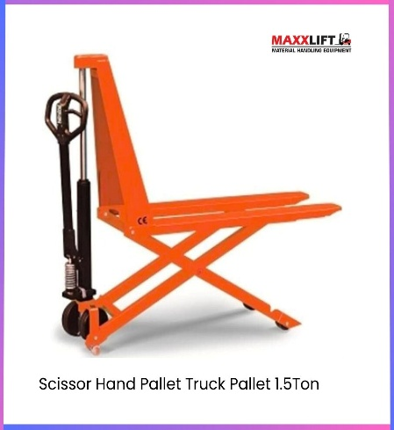

Technical Specifications
Parameter | Detail | Parameter | Detail
Model No. | Maxx-SHPT1.5T | Type | Manual Hydraulic Scissor Pallet Truck
Load Capacity | 1500 kg (1.5 Ton) | Maximum Platform Height | 1900 mm
Maximum Working Height | 850 mm | Fork Height (Max / Min) | 205 mm / 85 mm
Fork Length | 1150 mm | Fork Overall Width | 540 mm
Single Fork Width | 160 mm | Wheel Material | Polyurethane (PU)
Front Wheel Size | Ø80 × 60 mm | Rear Wheel Size | Ø200 × 50 mm
Frame Material | Heavy-Duty Steel | Net Weight | 85 kg

Applications
- Warehouses and small production units
- Material loading and stacking areas
- Packaging, inspection, and assembly stations
- Workshops and industrial facilities
Advantages
- Combines lifting and transport functions in one machine
- Improves operator comfort and efficiency
- Requires no power source – completely manual operation
- Compact size and smooth handling for confined spaces
- Built to MAXXLIFT’s high-quality industrial standards
Warranty & Support
12-month warranty covering hydraulic and structural components.
Service and spare parts available through MAXXLIFT branches in Sonipat, Gurugram, Kundli, and Bhiwadi.
On-site service available within 24–48 hours.
Contact Details
MAXXLIFT MOTORS PRIVATE LIMITED
Main Highway NH-44, GT Karnal Road, Kundli, Sonipat – Opposite KFC Restaurant, Haryana
9811679096 7678272743 9950921878 9218058170
www.maxxlift.in

Hydraulic Lift Table – 500 Kg Capacity
Model No. MAXX-500Kg Hydraulic Lift Table
Overview
The MAXXLIFT 500 Kg Hydraulic Lift Table is a scissor-type high-lift platform designed for safe and efficient material handling, assembly, and maintenance tasks.
Built with a strong steel frame and precision hydraulic system, it allows easy manual lifting of loads up to 500 Kg, making it ideal for workshop, warehouse, and production environments.
Its compact structure and stable operation provide both versatility and operator safety for industrial use.
Description
This versatile scissor lift table can be used as a manual transfer vehicle, lifting platform, assembly table, or workbench.
The fast-lift hydraulic cylinder improves work efficiency and ensures smooth operation.
At higher elevations, the supporting leg locks automatically, ensuring safe and stable performance.
The ergonomic long handle keeps the operator at a safe distance during operation, providing comfort and control.
Maintenance is simple thanks to its single-cylinder design and durable construction.Key Features
- Scissor-type hydraulic lifting mechanism with stable platform
- Handles load from 350 Kg – 1000 Kg (model dependent)
- Fast-lift oil cylinder for improved efficiency
- Supporting legs engage automatically at higher height for safety
- Long handle design for safe, easy manoeuvring
- Smooth, quiet lifting and lowering operation
- Compact and mobile —ideal for workshops, factories, and warehouses

PRODUCT VIDEO LINK-INSERT FROM INSTAGRAM//YOUTUBE
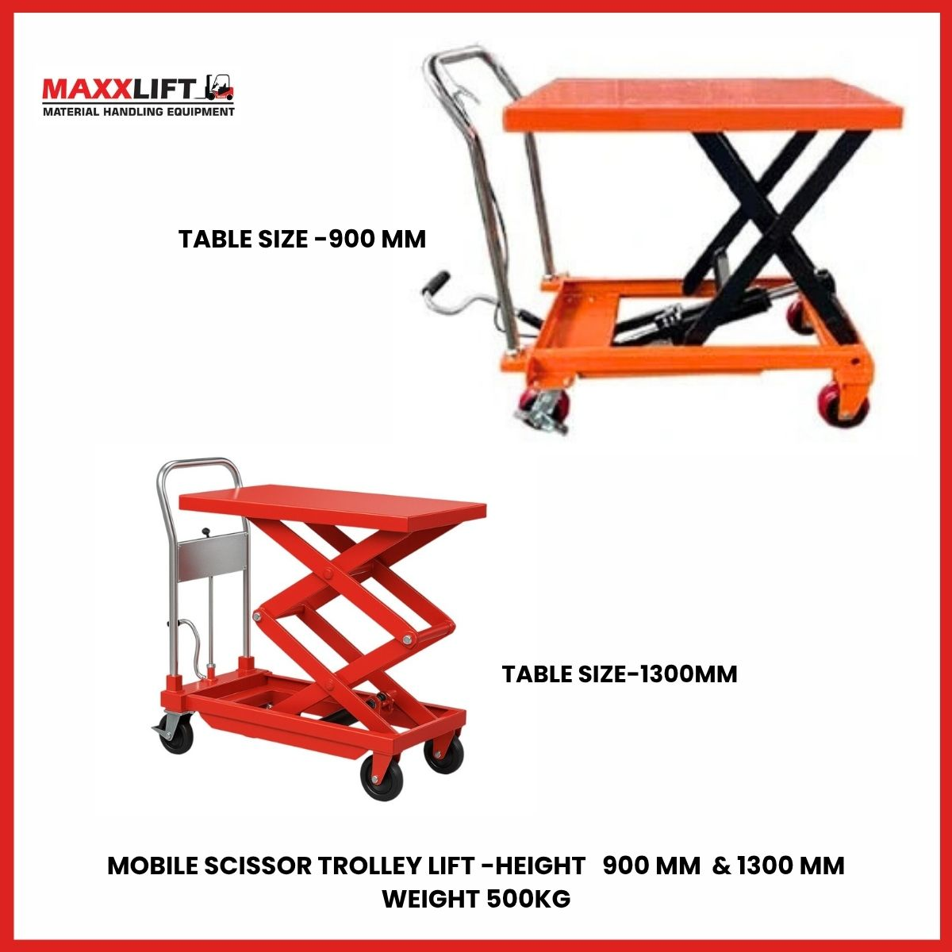
Technical Specifications

Parameter | Detail | Parameter | Detail
Model No. | MAXX-500Kg Hydraulic Lift Table | Type | Manual Hydraulic Scissor Lift Table
Rated Load | 500 Kg | Table Height (Max / Min) | 800 mm / 85 mm
Table Length | 1140 mm | Table Overall Width | 520 mm
Single Fork Width | 160 mm | Lifting Mechanism | Hydraulic Scissor Cylinder
Cylinder Type | Single Lift Cylinder | Handle Type | Long Manual Handle
Net Weight | 105 Kg | Frame Material | High-Strength Steel
Operation | Manual | Wheel Material | Polyurethane (PU)
Applications
- Assembly, inspection, and maintenance workstations
- Warehouses and workshops
- Packaging and production areas
- Factories and industrial plants
- Material lifting and short-distance transport
Advantages
- Combines lifting and transport functions in one compact design
- Reduces manual strain and increases productivity
- Stable platform with automatic safety support
- Low maintenance hydraulic system
- Easy to move and operate even in tight areas
Warranty & Support
Standard 12-month warranty on hydraulic and structural components.
Extended warranty and AMC available upon request.
MAXXLIFT provides installation, training, and service support through branches in Sonipat, Gurugram, Kundli, and Bhiwadi, with on-site assistance within 24–48 hours.
Contact Details
MAXXLIFT MOTORS PRIVATE LIMITED
Main Highway NH-44 GT Karnal Road Kundli Sonipat Opposite KFC Restaurant Haryana
9811679096 7678272743 9950921878 9218058170
www.maxxlift.in

Hand Pallet Truck Pallet 5Ton - Model No.: MAXX-HPT5T Brand: MAXXLIFT
Product Description
The MAXXLIFT 5 Ton Hand Pallet Truck is a heavy-duty manual hydraulic material handling trolley designed for smooth and efficient pallet movement in industrial environments.
Equipped with a manual hand brake system, it ensures safe parking and operation, especially on sloped or uneven warehouse floors.
Built using high-strength alloy steel, the fork structure provides excellent durability while maintaining a lightweight design for easy manoeuvrability.
This model is ideally suited for factories, logistics hubs, manufacturing units, warehouses, and construction sites where heavy loads are frequently lifted and moved manually.
Key Features
- 5 Ton Load Capacity – Designed for heavy-duty applications.
- Manual Hydraulic System – Smooth lifting and controlled lowering.
- Hand Brake Equipped – Added safety for operations on inclined surfaces.
- High-Strength Alloy Forks – Lightweight yet durable construction.
- PU Wheels – Ensures silent movement and protects warehouse flooring.
- Low Maintenance – Reliable AC-type hydraulic pump with long service life. Fork Length: Optimized for large pallet compatibility and safety
- Compact Design – Easy to operate and manoeuvre in tight spaces
- Heavy-Duty Frame: Made with strong, durable steel for long-term performance
- Manual Operation: Easy-to-use pallet truck requiring minimal physical effort
- Ergonomic Handle: Comfortable grip and smooth control with lever-operated mechanism
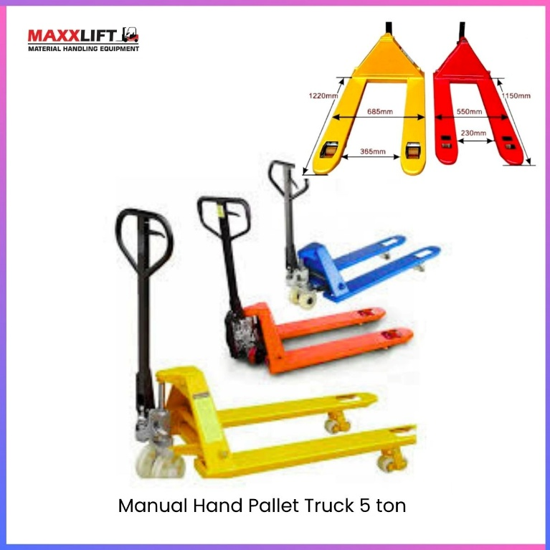

Technical Specifications
Parameter | Specification | Parameter | Specification
Model No. | MAXX-HPT5T | Product Type | Manual Hydraulic Hand Pallet Truck
Load Capacity | 5000 Kg | Fork Length | 1150 mm
Maximum Platform Height | 170 mm | Fork Overall Width | 540 mm
Single Fork Width | 160 mm | Load Centre Distance | 475 mm
Front Wheel Size | Φ80 × 60 mm | Rear Wheel Size | Φ200 × 50 mm
Wheel Material | Polyurethane (PU) | Net Weight | 90 Kg
Operation Type | Manual Hydraulic | Body Material | High-Strength Alloy Steel
Pump Type | AC Hydraulic Pump

Applications
- Heavy-duty warehouse loading/unloading
- Industrial logistics & storage areas
- Manufacturing & packaging units
- Transport hubs and construction sites
Maintenance & Service
- Use Hydraulic Oil No. 32/46 for pump refill.
- Regularly grease wheel bearings for smooth operation.
- Inspect handle linkage & seals every 6 months.
- Available service centres: Sonipat, Gurugram, Kundli, Bhiwadi
Warranty
- 1 Year Warranty on hydraulic and structural components.
- Spare parts and after-sales service provided by MAXXLIFT Motors Pvt. Ltd.

Manual Hand Pallet Truck – 3 Ton
Model No: MAXX–MHP 3.0 Ton
Description
The MAXXLIFT 3 Ton Hand Pallet Truck is a heavy-duty manual hydraulic trolley designed for industrial use, providing safe, smooth, and effortless material movement.
Equipped with a manual hand brake system, it ensures secure parking and control, especially on sloped warehouse floors.
Constructed from high-strength alloy steel, the fork design combines light weight with exceptional durability and load-bearing capacity.
This model is perfect for factories, logistics hubs, production units, and warehouses where consistent reliability and long service life are essential.
Key Features
- 3 Ton Load Capacity – Heavy-duty performance for demanding applications.
- Manual Hydraulic Lift System – Smooth and controlled lifting operation.
- Equipped with Hand Brake – For slope safety and load control.
- Lightweight Alloy Steel Frame – Strong yet easy to manoeuvre.
- PU Wheels – Low noise, wear-resistant, and floor-friendly.
- Compact Turning Radius – Designed for tight spaces and aisles.
- Low Maintenance – Reliable AC hydraulic pump system.
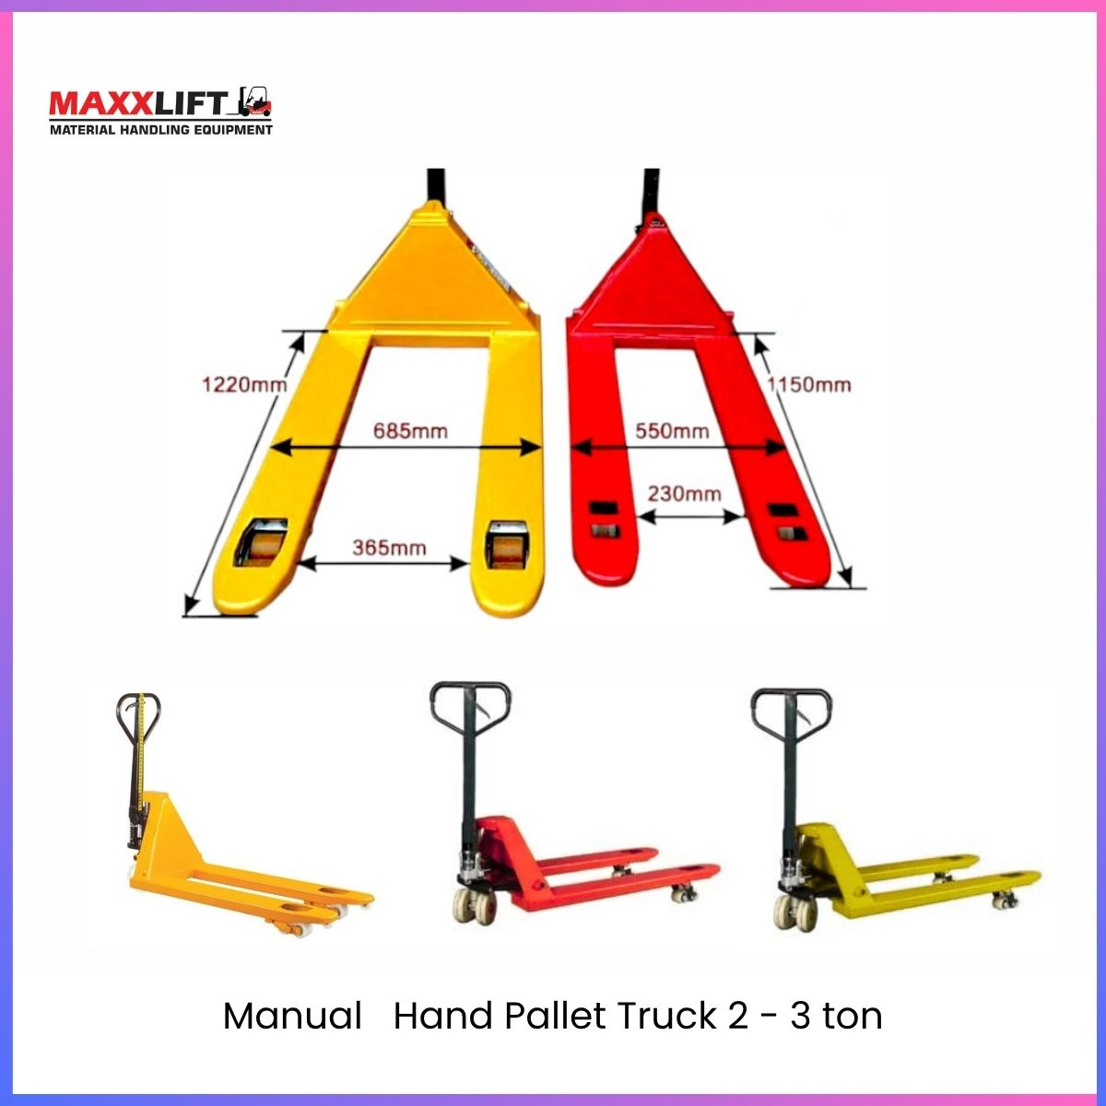
Technical Specifications

Parameter | Specification | Parameter | Specification
Model No. | MAXX–MHP–3.0 Ton | Product Type | Manual Hand Pallet Truck
Load Capacity | 3000 Kg | Operation Type | Hydraulic with Hand Brake
Maximum Platform Height | 160 mm | Maximum Working Height | 850 mm
Fork Height (Max/Min) | 205 mm / 85 mm | Fork Length | 1150 mm
Fork Overall Width | 540 mm | Single Fork Width | 160 mm
Front Wheel Size | Ø80 × 60 mm | Rear Wheel Size | Ø200 × 50 mm
Wheel Material | Polyurethane (PU) | Net Weight | 70 Kg
Pump Type | AC Hydraulic Pump | Frame Material | Alloy Steel
Surface Finish | Powder Coated | Colour Option | Red / Yellow

Applications
- Warehouses and distribution centres
- Industrial production plants
- Packaging and shipping areas
- Construction material handling
- Loading/unloading docks
Maintenance & Service
- Regularly check hydraulic oil and handle linkage.
- Lubricate wheel bearings and axles monthly.
- Store in a dry, dust-free environment.
- MAXXLIFT service centres: Sonipat, Gurugram, Kundli, Bhiwadi.
Warranty
- 1-Year Warranty on hydraulic and frame components.
- Lifetime after-sales support and spare parts availability from MAXXLIFT Motors Pvt. Ltd.

Electric Loader Unloader-Model No.: MAXX-Electric Loader Unloader
Product Description
The MAXXLIFT Electric Loader Unloader is a compact and efficient battery-operated lifting and transferring equipment, specially designed for loading and unloading goods in warehouses, delivery hubs, and factory floors.
Powered by a Ternary Lithium Battery, it provides high performance, longer operational hours, and smooth manoeuvrability with minimal maintenance.
Its electric-driven hydraulic system allows quick lifting, easy transport, and reliable operation for all types of material handling tasks — eliminating manual effort and improving workplace efficiency.
Key Features
- Fully Electric Operation – Easy loading/unloading with no manual pumping.
- Compact Design – Ideal for confined warehouse areas and container loading points.
- Powerful Ternary Lithium Battery – Ensures extended working hours and fast charging.
- Durable Steel Fork Design – High-strength structure with smooth operation.
- Easy Manoeuvrability – Large wheels ensure stability and effortless movement.
- Zero Emission & Low Noise – Environment-friendly and energy-efficient.

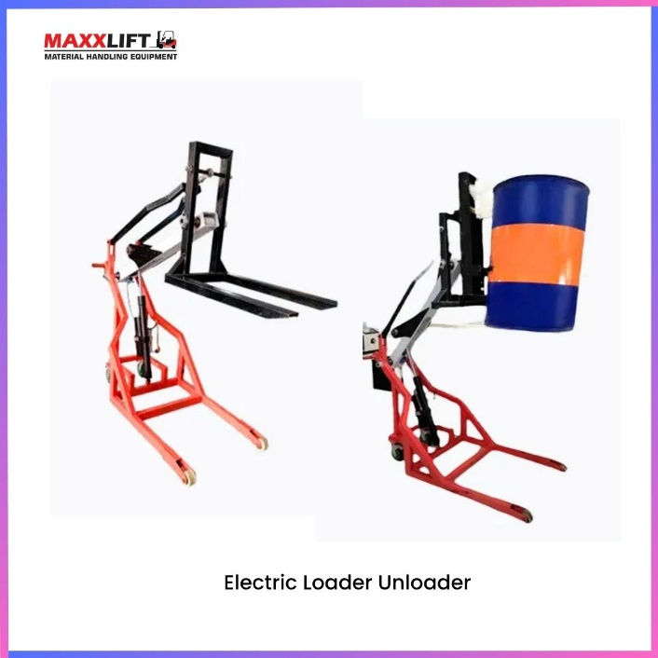
Technical Specifications
Parameter | Specification | Parameter | Specification
Model No. | Maxx -Electric Loader Unloader | Product Type | Battery Operated Material Handling Equipment
Wheel Diameter | 190 mm (19 cm) | Fork Length | 780 mm
Fork Outer Width | 470 mm | Fork Inner Width | 350 mm
Working Fork Outer Width | 700 mm | Working Fork Inner Width | 600 mm
Battery Type | Ternary Lithium Battery | Power Source | Electric
Overall Size (L × W × H) | 1780 × 700 × 900 mm | Operation Type | Electric Drive / Manual Steer
Frame Material | High-Strength Steel | Wheel Material | PU-Coated Industrial Rubber
Noise Level | Low (Silent Operation) | Maintenance | Minimal (No Oil Leakage)

Applications
- Container Loading & Unloading
- Warehouses and Distribution Centres
- Factories and Assembly Lines
- Logistics and Transport Hubs
- Retail Storage and Delivery Bays
Battery & Charging
- Battery Type: Ternary Lithium (Fast Charge, Deep Cycle)
- Charging Time: 4–5 Hours
- Operation Duration: Up to 6–8 Hours Continuous Use
- Charger Input: 220V AC Standard Socket
Maintenance & Service
- Keep battery terminals clean and charged regularly.
- Inspect wheel bearings and hydraulic unit every 6 months.
- Ensure charger is disconnected after full charge.
- Available service centres: Sonipat, Gurugram, Kundli, and Bhiwadi.
Warranty
- 1 Year Warranty on electrical and structural components.
- Lifetime service support and spare parts availability by MAXXLIFT Motors Pvt Ltd.

Manual/ Electric Reel Hand Pallet Truck – 3 Ton
Model No: MAXX–MRHP 3.0 Ton
Description
The MAXXLIFT 3 Ton Hand Reel Pallet Truck is a heavy-duty manual hydraulic trolley designed for industrial use, providing safe, smooth, and effortless material movement.
Equipped with a manual hand brake system, it ensures secure parking and control, especially on sloped warehouse floors.
Constructed from high-strength alloy steel, the fork design combines light weight with exceptional durability and load-bearing capacity.
This model is perfect for factories, logistics hubs, production units, and warehouses where consistent reliability and long service life are essential.
Key Features
- 3 Ton Load Capacity – Heavy-duty performance for demanding applications.
- Manual Hydraulic Lift System – Smooth and controlled lifting operation.
- Equipped with Hand Brake – For slope safety and load control.
- Lightweight Alloy Steel Frame – Strong yet easy to manoeuvre.
- PU Wheels – Low noise, wear-resistant, and floor-friendly.
- Compact Turning Radius – Designed for tight spaces and aisles.
- Low Maintenance – Reliable AC hydraulic pump system.
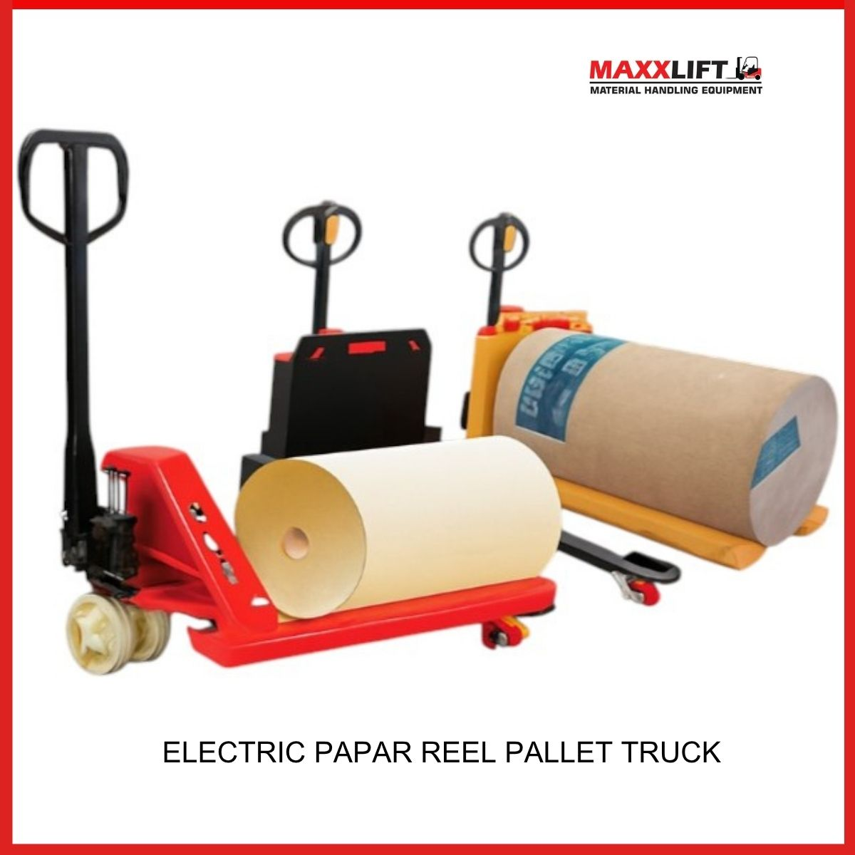
Technical Specifications

Parameter | Specification | Parameter | Specification
Model No. | MAXX–MRHP–3.0 Ton | Product Type | Manual Hand Pallet Truck
Load Capacity | 3000 Kg | Operation Type | Hydraulic with Hand Brake
Maximum Platform Height | 160 mm | Maximum Working Height | 850 mm
Fork Height (Max/Min) | 205 mm / 85 mm | Fork Length | 1150 mm
Fork Overall Width | 540 mm | Single Fork Width | 160 mm
Front Wheel Size | Ø80 × 60 mm | Rear Wheel Size | Ø200 × 50 mm
Wheel Material | Polyurethane (PU) | Net Weight | 70 Kg
Pump Type | AC Hydraulic Pump | Frame Material | Alloy Steel
Surface Finish | Powder Coated | Colour Option | Red / Yellow

Applications
- Warehouses and distribution centres
- Industrial production plants
- Packaging and shipping areas
- Construction material handling
- Loading/unloading docks
Maintenance & Service
- Regularly check hydraulic oil and handle linkage.
- Lubricate wheel bearings and axles monthly.
- Store in a dry, dust-free environment.
- MAXXLIFT service centres: Sonipat, Gurugram, Kundli, Bhiwadi.
Warranty
- 1-Year Warranty on hydraulic and frame components.
- Lifetime after-sales support and spare parts availability from MAXXLIFT Motors Pvt. Ltd.

